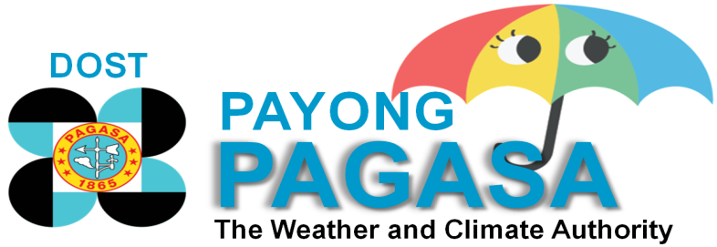

Link to images: http://i.imgur.com/vbyDsWw.jpg?1

Title: Statistically downscaled Coupled Model Intercomparison Project Phase 3 (CMIP3) Climate Change Projections (2011-2040)

Overview
Based on Intergovernmental Panel on Climate Change (IPCC, 2007b), changing climate is projected to have a number of impacts, including possible water shortages, decreased agricultural production and food security. With these considerations a joint project undertaking was forged with the Philippine Atmospheric, Geophysical, and Astronomical Services Administration (PAGASA) and the FAO-AMICAF (Food and Agriculture Organization of the United Nations) with the cooperation of the University of Cantabria in Spain. The project aims to assess vulnerability of households to food insecurity through the use of a tool called MOSAICC (Modelling System for Agricultural Impacts of Climate Change). Ultimately, climate information generated from the project can be used to provide relevant and updated climate information for national socioeconomic policy making.
The work plan was implemented through a series of workflow wherein PAGASA undertook the first step of the work plan which is the climate scenario downscaling. Global climate models (GCMs) were statistically downscaled at station level under the Coupled Model Intercomparison Project Phase 3 (CMIP3). These GCMs are BCM2, CNCM3, and MPEH5.
Results of climate projections are provided in two time period: historical (1971-2000) and projections (2011-2040) using two Special Report on Emission Scenarios (SRES): A1B (medium-range) and A2 (high-range). SRES are based on projected greenhouse gases emissions in future years.
There are three seasonal variables available for download: precipitation, minimum temperature, and maximum temperature. A technical note to help you understand our products is also available for download via this link.

VARIABLE | DATASET
Precipitation | Historical (1971-2000)
 | SRES A1B (2011-2040)
 | SRES A2 (2011-2040)
Minimum Temperature | Historical (1971-2000)
 | SRES A1B (2011-2040)
 | SRES A2 (2011-2040)
Maximum Temperature | Historical (1971-2000)
 | SRES A1B (2011-2040)
 | SRES A2 (2011-2040)
Note: You need Google Earth to visualize the downloaded products
References
(2014). Assessments of Climate Change Impacts and Mapping of Vulnerability to Food Insecurity under Climate Change to Strengthen Household Food Security with Livelihoods’ Adaptation Approaches (AMICAF): Project Terminal Report. Submitted to Food and Agriculture Organization of the United Nations Country Office in the Philippines. Quezon City: DOST-PAGASA.
Basconcillo, J., Lucero, A., Solis, A., Bautista, E., Sandoval, R., Kanamaru, H., Koizumi, T. (2014). Downscaled Projected Changes in Seasonal Mean Temperature and Rainfall in the Cagayan Valley, Philippines. Submitted to Journal of Meteorological Society of Japan.
Lucero, A., Basconcillo, J., Solis, A., Kanamaru, H., Bautista, E., Sandoval, R., Hilario, S., Juanillo, E., (2014). Recent Projected Changes (2011-2040) in Seasonal Mean Temperature and Rainfall in the Philippines. Paper presented at the 3rd National Climate Conference. Manila, Philippines.
Manzanas, R., Brands, S., San-Martin, D., Lucero, A., Limbo, C., Gutierrez, J. (2015) Statistical Downscaling in the Tropics is Sensitive to Reanalysis Choice. Journal of Climate., Vol. 28, 4171-4184
Signature Form
Kindly fill-up the information below before you can proceed with download. Your privacy will be kept secured. Thank you.
NAME:
AFFILIATION:
EMAIL ADDRESS:
TYPE OF AFFILIATION:
Type of Organization
- National Agency
- Local Government
- Commercial/Private Business
- Academic
- Others

Type of Industry (as many as applicable)
- Electric/Gas Utility
- Environment Management
- Fire
- Fisheries
- Protected Areas and Forestry
- Wildlife Conservation
- Climate Services
- Weather Services
- Health Services
- Human Resource Services
- Higher Education
- Defense and Law Enforcement
- Insurance
- Library, Museums, and Educational Services
- Location and GIS Services
- Media/Publishing
- Mining
- Natural Resources
- Planning and Economic Development
- Public Safety and Emergency Management
- Public Works and Survey
- Real Estate
- Commercial and Retail
- Telecommunication
- Transportation
- Tourism
- Water Resources
- Wastewater
- Others (please specify): ________

***Prompt will confirm submission of form to NEW ACCOUNT (climps@pagasa.dost.gov.ph)

Thank you! Your download will start in a shortwhile.
****after filling up the form, download will proceed***

