“AGHON” SLIGHTLY WEAKENS AS IT CROSSED TICAO ISLAND AND MASBATE CITY
Location of Center (1:00 PM) |  |  |  | 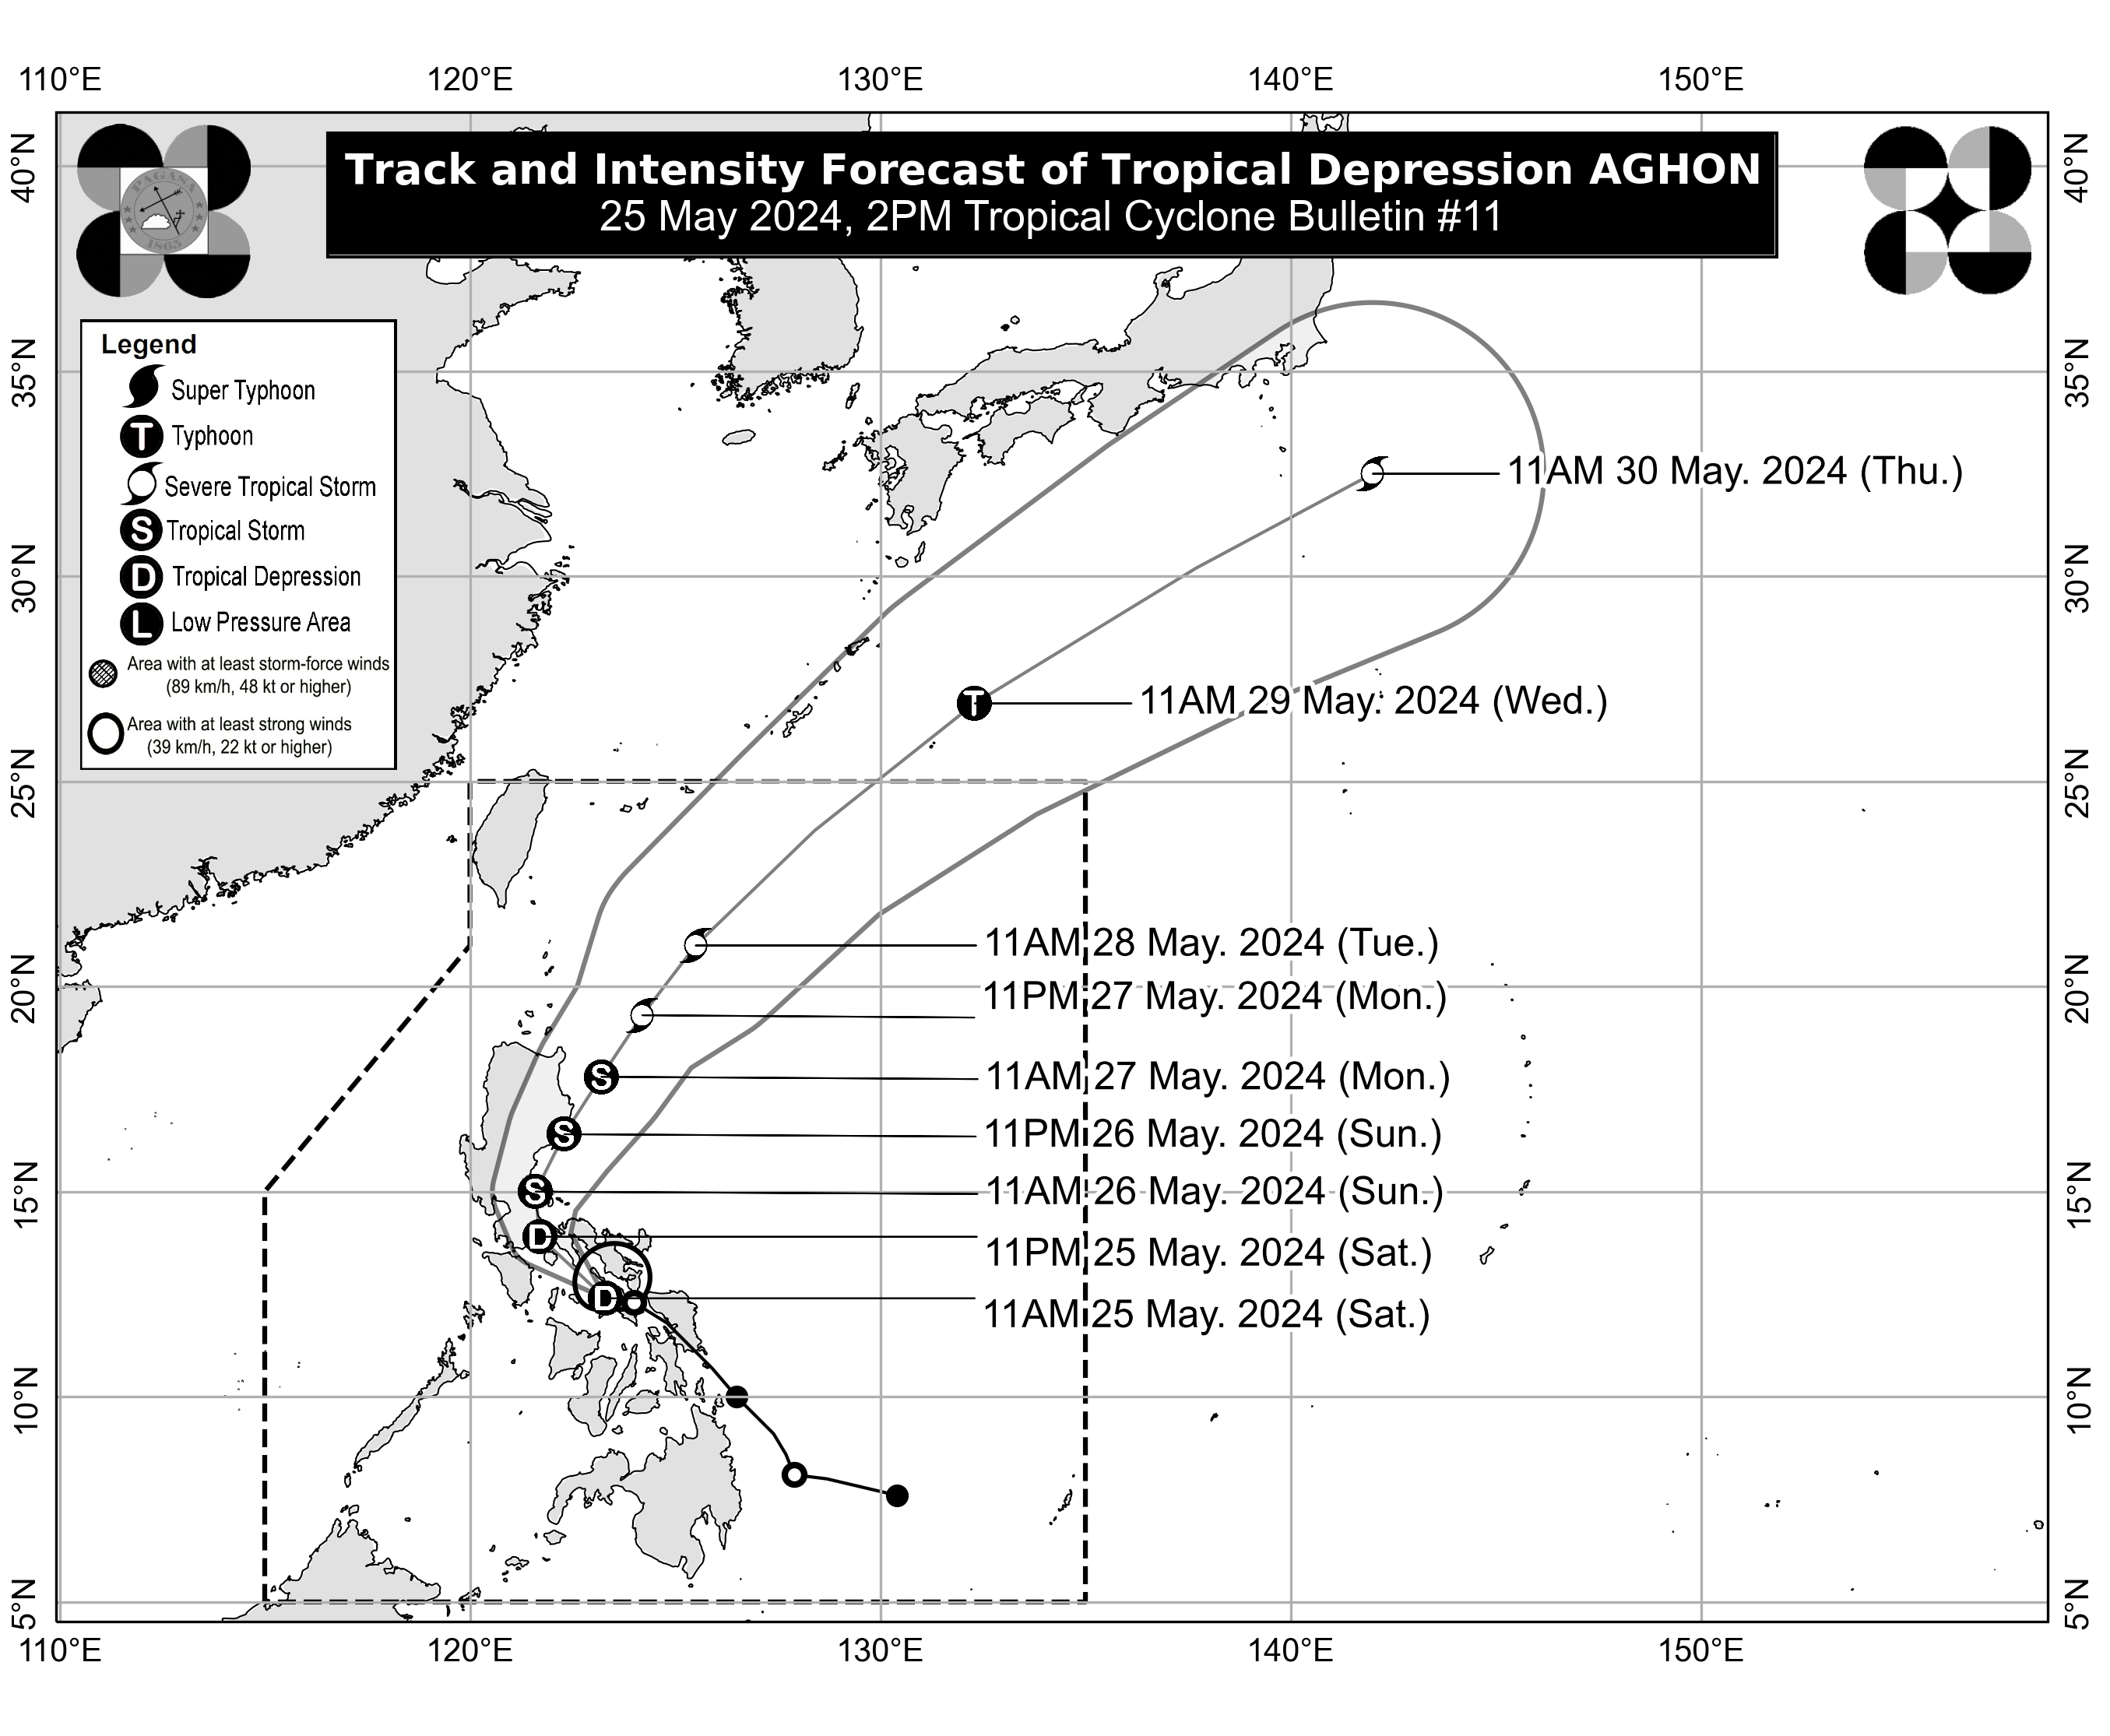
The center of Tropical Depression AGHON was estimated based on all available data over the coastal waters of Sibuyan Island (12.5°N, 122.9°E)
Intensity
Maximum sustained winds of 45 km/h near the center, gustiness of up to 70 km/h, and central pressure of 1006 hPa
Present Movement
West Northwestward at 30 km/h
Extent of Tropical Cyclone Winds
Strong winds extend outwards up to 110 km from the center
TRACK AND INTENSITY FORECAST
Date and Time | Center Position |  |  |  | Intensity |  | Movement dir. and speed (km/h)
 | Lat.  (°N) | Lon.  (°E) | Location |  | MSW  (km/h) | Cat.
12-Hour Forecast  11:00 PM  25 May 2024 | 13.9 | 121.7 | Over the coastal waters of Lucena City, Quezon |  | 55 | TD | NW 20
24-Hour Forecast  11:00 AM  26 May 2024 | 15.0 | 121.6 | Over the coastal waters of General Nakar, Quezon |  | 65 | TS | N 10
36-Hour Forecast  11:00 PM  26 May 2024 | 16.4 | 122.3 | Over the coastal waters of Casiguran, Aurora |  | 75 | TS | NNE 15
48-Hour Forecast  11:00 AM  27 May 2024 | 17.8 | 123.2 | 155 km East of Tuguegarao City, Cagayan |  | 85 | TS | NNE 15
60-Hour Forecast  11:00 PM  27 May 2024 | 19.3 | 124.2 | 285 km East of Calayan, Cagayan |  | 95 | STS | NNE 15
72-Hour Forecast  11:00 AM  28 May 2024 | 21.0 | 125.5 | 375 km East of Basco, Batanes |  | 100 | STS | NE 20
96-Hour Forecast  11:00 AM  29 May 2024 | 26.9 | 132.3 | 1,265 km Northeast of Extreme Northern Luzon (OUTSIDE PAR) |  | 120 | TY | NE 40
120-Hour Forecast  11:00 AM  30 May 2024 | 32.5 | 142.0 | 2,385 km Northeast of Extreme Northern Luzon (OUTSIDE PAR) |  | 95 | STS | NE 45

TROPICAL CYCLONE WIND SIGNALS (TCWS) IN EFFECT
TCWS No. | Luzon | Visayas | Mindanao
1  Wind threat: Strong winds | Aurora, the eastern portion of Nueva Ecija (General Tinio, Gabaldon), the eastern portion of Bulacan (Norzagaray, Doña Remedios Trinidad, City of San Jose del Monte), Metro Manila, Quezon including Pollilo Islands, Romblon (Cajidiocan, Magdiwang, San Fernando, Romblon, Corcuera, Banton, San Agustin, San Andres, Calatrava, Concepcion), Marinduque, Laguna, Rizal, Oriental Mindoro (Pinamalayan, Pola, Naujan, Victoria, Socorro, City of Calapan), Batangas (Lobo, Taysan, Rosario, Padre Garcia, San Juan, Santo Tomas), Sorsogon, Albay, Catanduanes, Camarines Sur, Camarines Norte, and Masbate including Ticao and Burias Islands | The northern portion of Northern Samar (Rosario, Biri, San Isidro, Capul, San Vicente, Victoria, Lavezares, San Antonio, San Jose, Allen, Bobon) and the northern portion of Samar (Tagapul-An) | -
Warning lead time: 36 hours
Range of wind speeds: 39 to 61 km/h (Beaufort 6 to 7)
Potential impacts of winds: Minimal to minor threat to life and property

HAZARDS AFFECTING LAND AREAS
Heavy Rainfall Outlook

Forecast accumulated rainfall: Today to tomorrow noon
- 100-200 mm: Quezon including Polillo Islands, the eastern portions of Laguna and Rizal, Marinduque, Romblon, and Bicol Region
- 50-100 mm: Eastern portion of Isabela, Aurora, Metro Manila, the rest of Rizal, the rest of Laguna, and the northern portion of Western Visayas

Forecast accumulated rainfall: Tomorrow noon to Monday noon
- 100-200 mm: Quezon including Polillo Islands, Camarines Norte, Camarines Sur, and Catanduanes.
- 50-100 mm: Aurora, the rest of Bicol Region, and the eastern portions of Isabela, Laguna, and Rizal

Forecast rainfall are generally higher in elevated or mountainous areas. Under these conditions, flooding and rain-induced landslides are possible especially in areas that are highly or very highly susceptible to these hazards as identified in hazard maps and in localities that experienced considerable amounts of rainfall for the past several days.
Severe Winds

The wind signals warn the public of the general wind threat over an area due to the tropical cyclone. Local winds may be slightly stronger/enhanced in coastal and upland/mountainous areas exposed to winds. Winds are less strong in areas sheltered from the prevailing wind direction.

- Minimal to minor impacts from strong winds are possible within any of the areas under Wind Signal No. 1.

Other areas in CALABARZON, MIMAROPA, and Central Luzon may be placed under Wind Signal No.1 in the next bulletin. The highest possible Wind Signal that may be hoisted during the passage of AGHON is Wind Signal No. 2.

HAZARDS AFFECTING COASTAL WATERS
Today: AGHON will bring moderate to rough seas (1.5 to 3.5 m) over the coastal waters along the seaboards of Bicol Region, Quezon, the eastern seaboard of Eastern Visayas, and the western seaboard of Samar and Northern Samar. Mariners of motor bancas and similarly-sized vessels are advised to take precautionary measures while venturing out to sea and, if possible, avoid navigating in these conditions, especially if inexperienced or operating ill-equipped vessels.

TRACK AND INTENSITY OUTLOOK
- AGHON is forecast to move generally west northwestward to northwestward over Sibuyan Sea and Tayabas Bay, and may possibly make landfall over Marinduque within the next 12 hours. During this period, further weakening into Low Pressure Area (LPA) is not ruled out. AGHON will then continue to move northward and may possibly make another landfall over Lucena City or Pagbilao, Quezon and emerge over Lamon Bay by tomorrow morning. Re-intensification is possible and it may reach tropical storm category by tomorrow morning.
- Around tomorrow afternoon or evening, AGHON will begin to recurve towards the northeast. As it moves over the Philippine Sea, the tropical cyclone is forecast to continuously intensify and may reach typhoon category on Tuesday evening or Wednesday morning. On the track forecast, AGHON may exit the PAR region no earlier than Tuesday.

Considering these developments, the public and disaster risk reduction and management offices concerned are advised to take all necessary measures to protect life and property. Persons living in areas identified to be highly or very highly susceptible to these hazards are advised to follow evacuation and other instructions from local officials. For heavy rainfall warnings, thunderstorm/rainfall advisories, and other severe weather information specific to your area, please monitor products issued by your local PAGASA Regional Services Division.

The next tropical cyclone bulletin will be issued at 5:00 PM today.

DOST-PAGASA

