“AGHON” CONTINUES TO MOVE WEST NORTHWESTWARD AND IS NOW OVER THE COASTAL WATERS OF SAN FRANCISCO, QUEZON
Location of Center (7:00 PM) |  |  |  | 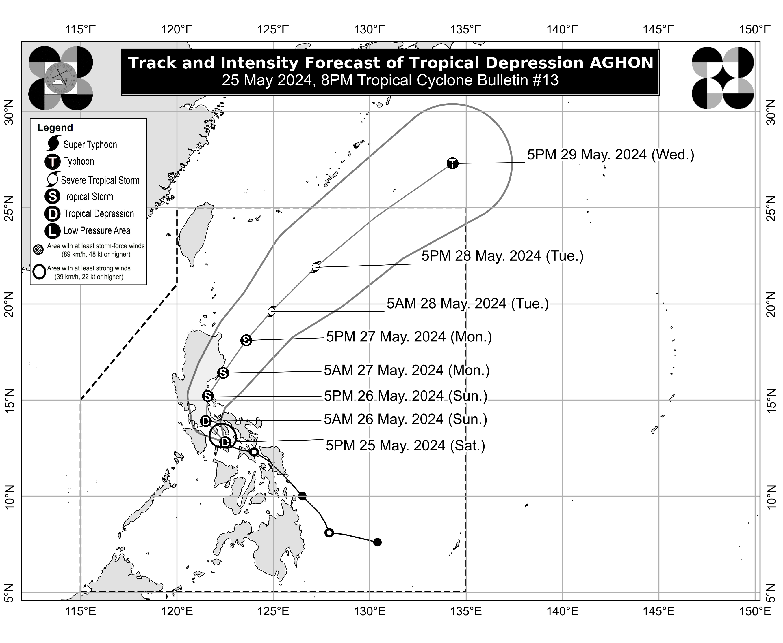
The center of Tropical Depression AGHON was estimated based on all available data over the coastal waters of San Francisco, Quezon (13.0°N, 122.4°E)
Intensity
Maximum sustained winds of 45 km/h near the center, gustiness of up to 70 km/h, and central pressure of 1006 hPa
Present Movement
West Northwestward at 15 km/h
Extent of Tropical Cyclone Winds
Strong winds extend outwards up to 110 km from the center
TRACK AND INTENSITY FORECAST
Date and Time | Center Position |  |  |  | Intensity |  | Movement dir. and speed (km/h)
 | Lat.  (°N) | Lon.  (°E) | Location |  | MSW  (km/h) | Cat.
12-Hour Forecast  5:00 AM  26 May 2024 | 13.9 | 121.5 | In the vicinity of Sariaya, Quezon |  | 55 | TD | NW 15
24-Hour Forecast  5:00 PM  26 May 2024 | 15.2 | 121.6 | Over the coastal waters of General Nakar, Quezon |  | 65 | TS | N 10
36-Hour Forecast  5:00 AM  27 May 2024 | 16.4 | 122.4 | Over the coastal waters of Dilasag, Aurora |  | 75 | TS | NNE 15
48-Hour Forecast  5:00 PM  27 May 2024 | 18.1 | 123.6 | 210 km East of Aparri, Cagayan |  | 85 | TS | NE 20
60-Hour Forecast  5:00 AM  28 May 2024 | 19.6 | 124.9 | 360 km East of Calayan, Cagayan |  | 100 | STS | NE 20
72-Hour Forecast  5:00 PM  28 May 2024 | 21.9 | 127.2 | 565 km East Northeast of Basco, Batanes |  | 110 | STS | NE 30
96-Hour Forecast  5:00 PM  29 May 2024 | 27.3 | 134.3 | 1,460 km East Northeast of Extreme Northern Luzon (OUTSIDE PAR) |  | 120 | TY | NE 40

TROPICAL CYCLONE WIND SIGNALS (TCWS) IN EFFECT
TCWS No. | Luzon | Visayas | Mindanao
1  Wind threat: Strong winds | Quirino (Maddela, Nagtipunan), Nueva Vizcaya (Alfonso Castaneda), Nueva Ecija (General Tinio, Gabaldon, Bongabon, Pantabangan, Rizal, General Mamerto Natividad, Laur, Palayan City, Peñaranda, San Leonardo, City of Gapan, Cabanatuan City, Santa Rosa, San Isidro, Cabiao, San Antonio, Jaen), Pampanga (Candaba, San Luis, San Simon, Apalit, Santa Ana, Arayat), Bulacan, Aurora, Metro Manila, Cavite (Mendez, Gen. Mariano Alvarez, Noveleta, Silang, City of Dasmariñas, City of General Trias, Amadeo, Carmona, Kawit, Rosario, Tanza, Alfonso, Tagaytay City, Bacoor City, Trece Martires City, Imus City, Indang), Laguna, Rizal, Batangas (Lobo, Taysan, Rosario, Padre Garcia, San Juan, Santo Tomas, Batangas City, Tingloy, Bauan, San Luis, Mabini, San Pascual, San Jose, Ibaan, Lipa City, Mataasnakahoy, Balete, Malvar, Calaca, Cuenca, Talisay, Agoncillo, Lemery, City of Tanauan, Alitagtag, San Nicolas, Laurel, Santa Teresita, Taal), Quezon including Polillo Islands, Camarines Norte, Camarines Sur, Catanduanes, Albay, Sorsogon (Pilar, Castilla, Donsol, City of Sorsogon), Masbate including Burias Island, Oriental Mindoro (Pinamalayan, Pola, Naujan, Victoria, Socorro, City of Calapan, Bansud, Gloria, Baco, San Teodoro, Puerto Galera, Bongabong, Roxas), Occidental Mindoro (Sablayan, Abra de Ilog), Marinduque, and Romblon | - | -
Warning lead time: 36 hours
Range of wind speeds: 39 to 61 km/h (Beaufort 6 to 7)
Potential impacts of winds: Minimal to minor threat to life and property

HAZARDS AFFECTING LAND AREAS
Heavy Rainfall Outlook

Forecast accumulated rainfall: From tonight to tomorrow evening
- 100-200 mm: Quezon including Polillo Islands, the eastern portions of Laguna and Rizal, Marinduque, Romblon, Camarines Norte, Camarines Sur, and Catanduanes
- 50-100 mm: Eastern portion of Isabela, Aurora, Metro Manila, the rest of CALABARZON, Oriental Mindoro, Occidental Mindoro, and the northern portion of Western Visayas

Forecast accumulated rainfall: From tomorrow evening to Monday evening
- 100-200 mm: Quezon including Polillo Islands, Camarines Norte, Camarines Sur, and Catanduanes.
- 50-100 mm: Aurora, the eastern portions of Isabela, Laguna, Rizal, Albay, and the northern portion of Masbate including Burias Island

Forecast rainfall are generally higher in elevated or mountainous areas. Under these conditions, flooding and rain-induced landslides are possible especially in areas that are highly or very highly susceptible to these hazards as identified in hazard maps and in localities that experienced considerable amounts of rainfall for the past several days.
Severe Winds

The wind signals warn the public of the general wind threat over an area due to the tropical cyclone. Local winds may be slightly stronger/enhanced in coastal and upland/mountainous areas exposed to winds. Winds are less strong in areas sheltered from the prevailing wind direction.

- Minimal to minor impacts from strong winds are possible within any of the areas under Wind Signal No. 1.

Other areas in CALABARZON, MIMAROPA, Central Luzon, and Cagayan Valley may be placed under Wind Signal No.1 in the next bulletin. The highest possible Wind Signal that may be hoisted during the passage of AGHON is Wind Signal No. 2.

HAZARDS AFFECTING COASTAL WATERS
Tonight: AGHON will bring moderate to rough seas (1.5 to 3.5 m) over the coastal waters along the seaboards of CALABARZON, MIMAROPA, Bicol Region, and the northern seaboards of Western Visayas. Mariners of motor bancas and similarly-sized vessels are advised to take precautionary measures while venturing out to sea and, if possible, avoid navigating in these conditions, especially if inexperienced or operating ill-equipped vessels.

TRACK AND INTENSITY OUTLOOK
- AGHON is forecast to move generally northwestward over Sibuyan Sea and Tayabas Bay, and may possibly make landfall over Marinduque within the next 12 hours. During this period, weakening into Low Pressure Area (LPA) is not ruled out. AGHON will then continue to move northwestward and may possibly make another landfall over Batangas or Quezon and traverse CALABARZON area. Re-intensification is possible and it may reach tropical storm category by tomorrow as AGHON emerges over Polillo Strait.
- Around tomorrow afternoon or evening, AGHON will begin to recurve towards the northeast. As it moves over the Philippine Sea, the tropical cyclone is forecast to continuously intensify and may reach typhoon category on Wednesday. On the track forecast, AGHON may exit the PAR region no earlier than Tuesday.

Considering these developments, the public and disaster risk reduction and management offices concerned are advised to take all necessary measures to protect life and property. Persons living in areas identified to be highly or very highly susceptible to these hazards are advised to follow evacuation and other instructions from local officials. For heavy rainfall warnings, thunderstorm/rainfall advisories, and other severe weather information specific to your area, please monitor products issued by your local PAGASA Regional Services Division.

The next tropical cyclone bulletin will be issued at 11:00 PM today.

DOST-PAGASA

