TROPICAL DEPRESSION “AGHON” HAS MADE ANOTHER LANDFALL IN TORRIJOS, MARINDUQUE
Location of Center (10:00 PM) |  |  |  | 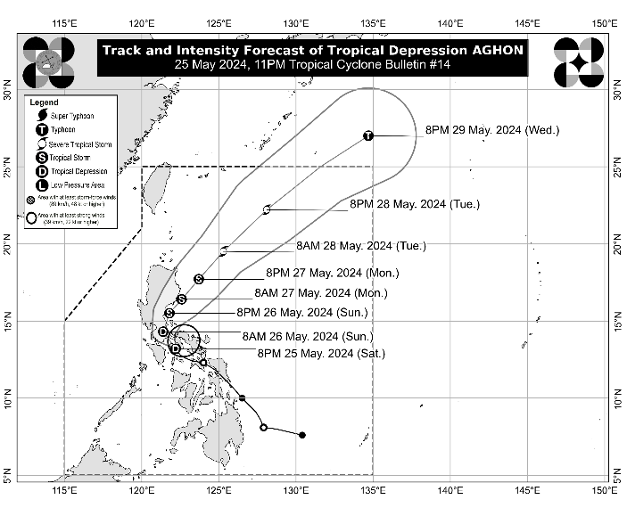
The center of Tropical Depression AGHON was estimated based on all available data in the vicinity of Torrijos, Marinduque (13.3°N, 122.0°E)
Intensity
Maximum sustained winds of 55 km/h near the center, gustiness of up to 75 km/h, and central pressure of 1004 hPa
Present Movement
Northwestward at 15 km/h
Extent of Tropical Cyclone Winds
Strong winds extend outwards up to 200 km from the center
TRACK AND INTENSITY FORECAST
Date and Time | Center Position |  |  |  | Intensity |  | Movement dir. and speed (km/h)
 | Lat.  (°N) | Lon.  (°E) | Location |  | MSW  (km/h) | Cat.
12-Hour Forecast  8:00 AM  26 May 2024 | 14.3 | 121.4 | In the vicinity of Santa Cruz, Laguna |  | 55 | TD | NW 10
24-Hour Forecast  8:00 PM  26 May 2024 | 15.5 | 121.8 | Over the coastal waters of San Luis, Aurora |  | 65 | TS | NNE 10
36-Hour Forecast  8:00 AM  27 May 2024 | 16.4 | 122.6 | Over the coastal waters of Dilasag, Aurora |  | 75 | TS | NE 10
48-Hour Forecast  8:00 PM  27 May 2024 | 17.7 | 123.7 | 205 km East of Tuguegarao City, Cagayan |  | 85 | TS | NE 15
60-Hour Forecast  8:00 AM  28 May 2024 | 19.5 | 125.3 | 405 km East of Calayan, Cagayan |  | 100 | STS | NE 20
72-Hour Forecast  8:00 PM  28 May 2024 | 22.2 | 128.1 | 665 km East Northeast of Itbayat, Batanes |  | 110 | STS | NE 35
96-Hour Forecast  8:00 PM  29 May 2024 | 27.0 | 134.7 | 1,480 km East Northeast of Extreme Northern Luzon (OUTSIDE PAR) |  | 120 | TY | NE 35

TROPICAL CYCLONE WIND SIGNALS (TCWS) IN EFFECT
TCWS No. | Luzon | Visayas | Mindanao
1  Wind threat: Strong winds | The southeastern portion of Isabela (Palanan, Dinapigue), the southern portion of Quirino (Maddela, Nagtipunan), the southern portion of Nueva Vizcaya (Alfonso Castaneda), the eastern and southern portions of Nueva Ecija (General Tinio, Gabaldon, Bongabon, Pantabangan, Rizal, General Mamerto Natividad, Laur, Palayan City, Peñaranda, San Leonardo, City of Gapan, Cabanatuan City, Santa Rosa, San Isidro, Cabiao, San Antonio, Jaen), Aurora, the eastern portion of Pampanga (Candaba, San Luis, San Simon, Apalit, Santa Ana, Arayat), Bulacan, Metro Manila, Quezon, Rizal, Laguna, the eastern portion of Cavite (Mendez, Gen. Mariano Alvarez, Noveleta, Silang, City of Dasmariñas, City of General Trias, Amadeo, Carmona, Kawit, Rosario, Tanza, Alfonso, Tagaytay City, Bacoor City, Trece Martires City, Imus City, Indang), the eastern portion of Batangas (Lobo, Taysan, Rosario, Padre Garcia, San Juan, Santo Tomas, Batangas City, Tingloy, Bauan, San Luis, Mabini, San Pascual, San Jose, Ibaan, Lipa City, Mataasnakahoy, Balete, Malvar, Calaca, Cuenca, Talisay, Agoncillo, Lemery, City of Tanauan, Alitagtag, San Nicolas, Laurel, Santa Teresita, Taal), the northern portion of Oriental Mindoro (Pinamalayan, Pola, Naujan, Victoria, Socorro, City of Calapan, Bansud, Gloria, Baco, San Teodoro, Puerto Galera, Bongabong, Roxas), portions of Occidental Mindoro (Sablayan, Abra de Ilog), Marinduque, Romblon, Camarines Norte, Camarines Sur, Catanduanes, Albay, and Burias Island | - | -
Warning lead time: 36 hours
Range of wind speeds: 39 to 61 km/h (Beaufort 6 to 7)
Potential impacts of winds: Minimal to minor threat to life and property

HAZARDS AFFECTING LAND AREAS
Heavy Rainfall Outlook

Forecast accumulated rainfall: From tonight until tomorrow evening
- > 200 mm: Quezon including Polillo Islands
- 100-200 mm: The southern portion of Aurora, the eastern portion of Bulacan, Rizal, Laguna, Marinduque, and Camarines Norte
- 50-100 mm: The rest of Aurora, Nueva Ecija, the rest of Bulacan, the eastern portion of Pampanga, Metro Manila, the rest of CALABARZON, Oriental Mindoro, Occidental Mindoro, Romblon, Burias Island, and Camarines Sur.

Forecast accumulated rainfall: From tomorrow evening to Monday evening
- 100-200 mm: Polillo Islands
- 50-100 mm: The eastern portion of Isabela, Aurora, the northern portion of Quezon, the eastern portions of Bulacan and Rizal, and Camarines Norte.

Forecast rainfall are generally higher in elevated or mountainous areas. Under these conditions, flooding and rain-induced landslides are likely especially in areas that are highly or very highly susceptible to these hazards as identified in hazard maps and in localities that experienced considerable amounts of rainfall for the past several days
Severe Winds

The wind signals warn the public of the general wind threat over an area due to the tropical cyclone. Local winds may be slightly stronger/enhanced in coastal and upland/mountainous areas exposed to winds. Winds are less strong in areas sheltered from the prevailing wind direction.

- Minimal to minor impacts from strong winds are possible within any of the areas under Wind Signal No. 1.

The highest possible Wind Signal that may be hoisted during the passage of AGHON is Wind Signal No. 2.

HAZARDS AFFECTING COASTAL WATERS
Tonight to tomorrow evening: AGHON will bring moderate to rough seas (1.5 to 3.5 m) over the coastal waters along the northern and eastern seaboards of Luzon and the southern seaboard of Quezon and Bicol Region. Mariners of motor bancas and similarly-sized vessels are advised to take precautionary measures while venturing out to sea and, if possible, avoid navigating in these conditions, especially if inexperienced or operating ill-equipped vessels.

TRACK AND INTENSITY OUTLOOK
- AGHON is forecast to move northwestward or north northwestward and make another landfall in mainland Quezon in the next 12 hours. Afterwards, the tropical cyclone will begin turning north northeastward and emerge over the waters east of Aurora by tomorrow afternoon or evening. \\AGHON will move generally northeastward movement for the remainder of the forecast period while gradually accelerating. On the track forecast, AGHON may leave the Philippine Area of Responsibility (PAR) by Wednesday.
- AGHON is forecast to remain a Tropical Depression while traversing Luzon over the next 12 hours. Once over the waters east of Aurora, it may begin to intensify and reach tropical storm category tomorrow evening. Further intensification is likely for the remainder of the forecast period and may reach a peak of severe tropical storm category or typhoon while inside the PAR region.

Considering these developments, the public and disaster risk reduction and management offices concerned are advised to take all necessary measures to protect life and property. Persons living in areas identified to be highly or very highly susceptible to these hazards are advised to follow evacuation and other instructions from local officials. For heavy rainfall warnings, thunderstorm/rainfall advisories, and other severe weather information specific to your area, please monitor products issued by your local PAGASA Regional Services Division.

The next tropical cyclone bulletin will be issued at 2:00 AM tomorrow.

DOST-PAGASA

