“AGHON” MAINTAINS ITS STRENGTH AND IS NOW OVER DOLORES, QUEZON.
Location of Center (7:00 AM) |  |  |  | 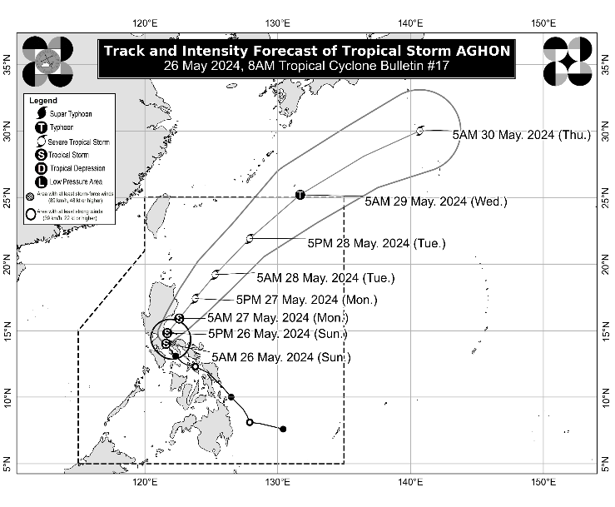
The center of Tropical Storm AGHON was estimated based on all available data including those from Tagaytay Doppler Weather Radar in the vicinity of Dolores, Quezon (14.0°N, 121.4°E)
Intensity
Maximum sustained winds of 65 km/h near the center, gustiness of up to 110 km/h, and central pressure of 998 hPa
Present Movement
Northwestward at 15 km/h
Extent of Tropical Cyclone Winds
Strong to gale-force winds extend outwards up to 220 km from the center
TRACK AND INTENSITY FORECAST
Date and Time | Center Position |  |  |  | Intensity |  | Movement dir. and speed (km/h)
 | Lat.  (°N) | Lon.  (°E) | Location |  | MSW  (km/h) | Cat.
12-Hour Forecast  5:00 PM  26 May 2024 | 14.8 | 121.7 | Over the coastal waters of Infanta, Quezon |  | 75 | TS | N Slowly
24-Hour Forecast  5:00 AM  27 May 2024 | 15.9 | 122.6 | 65 km Southeast of Casiguran, Aurora |  | 85 | TS | NE 15
36-Hour Forecast  5:00 PM  27 May 2024 | 17.4 | 123.8 | 220 km East of Tuguegarao City, Cagayan |  | 95 | STS | NE 15
48-Hour Forecast  5:00 AM  28 May 2024 | 19.2 | 125.3 | 405 km East of Calayan, Cagayan |  | 100 | STS | NE 20
60-Hour Forecast  5:00 PM  28 May 2024 | 21.9 | 127.9 | 640 km East Northeast of Itbayat, Batanes |  | 110 | STS | NE 35
72-Hour Forecast  5:00 AM  29 May 2024 | 25.2 | 131.7 | 1,125 km East Northeast of Extreme Northern Luzon (OUTSIDE PAR) |  | 120 | TY | NE 45
96-Hour Forecast  5:00 AM  30 May 2024 | 30.0 | 140.7 | 2,150 km East Northeast of Extreme Northern Luzon (OUTSIDE PAR) |  | 110 | STS | ENE 45

TROPICAL CYCLONE WIND SIGNALS (TCWS) IN EFFECT
TCWS No. | Luzon | Visayas | Mindanao
2  Wind threat: Gale-force winds | The northern and central portions of Quezon (Alabat, Perez, Quezon, Gumaca, Lopez, Macalelon, General Luna, Unisan, Pitogo, Plaridel, Agdangan, Padre Burgos, Atimonan, Mauban, Real, General Nakar, Infanta, Sampaloc, Pagbilao, Calauag, Lucban, City of Tayabas, Lucena City, Tiaong, Candelaria, Sariaya, Dolores, San Antonio) including Polillo Islands, Laguna, the eastern portion of Rizal (Jala-Jala, Pililla, Tanay), and the eastern portion of Batangas (City of Tanauan, San Jose, Lipa City, Mataasnakahoy, Balete, Malvar, Santo Tomas, Cuenca, San Pascual, Batangas City, Ibaan, Padre Garcia, Rosario, San Juan, Taysan, Lobo) | - | -
Warning lead time: 24 hours
Range of wind speeds: 62 to 88 km/h (Beaufort 8 to 9)
Potential impacts of winds: Minor to moderate threat to life and property
1  Wind threat: Strong winds | The southeastern portion of Isabela (Palanan, Dinapigue), the southern portion of Quirino (Maddela, Nagtipunan), the southern portion of Nueva Vizcaya (Alfonso Castaneda), the eastern and southern portions of Nueva Ecija (General Tinio, Gabaldon, Bongabon, Pantabangan, Rizal, General Mamerto Natividad, Laur, Palayan City, Peñaranda, San Leonardo, City of Gapan, Cabanatuan City, Santa Rosa, San Isidro, Cabiao, San Antonio, Jaen), Aurora, the eastern portion of Pampanga (Candaba, San Luis, San Simon, Apalit, Santa Ana, Arayat), Bulacan, Metro Manila, the rest of Quezon, the rest of Rizal, Cavite, the rest of Batangas, the northern portion of Oriental Mindoro (Pinamalayan, Pola, Naujan, Victoria, Socorro, City of Calapan, Bansud, Gloria, Baco, San Teodoro, Puerto Galera, Bongabong, Roxas), Marinduque, Romblon, Camarines Norte, Camarines Sur, the northern portion of Albay (Tiwi, Polangui, Malinao, Libon, Oas, City of Ligao), and Burias Island | - | -
Warning lead time: 36 hours
Range of wind speeds: 39 to 61 km/h (Beaufort 6 to 7)
Potential impacts of winds: Minimal to minor threat to life and property

HAZARDS AFFECTING LAND AREAS
Heavy Rainfall Outlook

Forecast accumulated rainfall: Today
- > 200 mm: Quezon
- 100-200 mm: Aurora, the eastern portion of Bulacan, Rizal, Laguna, Metro Manila, and Camarines Norte
- 50-100 mm: The eastern portion of Isabela, Nueva Ecija, the rest of Bulacan, the eastern portion of Pampanga, the rest of CALABARZON, Oriental Mindoro, Occidental Mindoro, Romblon, Burias Island, the western portion of Camarines Sur, Cuyo Islands, Aklan, and Antique.

Forecast accumulated rainfall: Tomorrow
- 50-100 mm: The eastern portion of Isabela, the northern portion of Aurora, and Polillo Islands.

Forecast rainfall are generally higher in elevated or mountainous areas. Under these conditions, flooding and rain-induced landslides are likely especially in areas that are highly or very highly susceptible to these hazards as identified in hazard maps and in localities that experienced considerable amounts of rainfall for the past several days
Severe Winds

The wind signals warn the public of the general wind threat over an area due to the tropical cyclone. Local winds may be slightly stronger/enhanced in coastal and upland/mountainous areas exposed to winds. Winds are less strong in areas sheltered from the prevailing wind direction.

- Minor to moderate impacts from strong winds are possible within any of the localities where Wind Signal No. 2 is hoisted.
- Minimal to minor impacts from strong winds are possible within any of the areas under Wind Signal No. 1.

The highest possible Wind Signal that may be hoisted during the passage of AGHON is Wind Signal No. 2.
Coastal Inundation

Within the next 24 hours, there is a minimal to moderate risk of storm surge over the exposed and low-lying coastal areas of Cagayan, Isabela, Aurora, Central Luzon, Metro Manila, CALABARZON, Mindoro Provinces, Marinduque, Romblon, Camarines Norte, Camarines Sur, Albay (west coast), Burias Island, mainland Masbate (northwest coast), and Aklan. For more information, refer to Storm Surge Warning No. 1 issued at 8:00 AM today.

HAZARDS AFFECTING COASTAL WATERS
- Under the influence of AGHON, a Gale Warning is hoisted over the coastal waters of Marinduque and Quezon, the southern coastal waters of Batangas, and the northern coastal waters of Camarines Norte. Sea travel is risky for small seacrafts, including all motorbancas of any type of tonnage. For more information, refer to Gale Warning No. 1 issued at 5:00 AM today.
- Today: Outside the Gale Warning areas, AGHON will bring moderate to rough seas (1.5 to 3.5 m) over the coastal waters along the northern and eastern seaboards of Luzon and the seaboard of Bicol Region. Mariners of motor bancas and similarly-sized vessels are advised to take precautionary measures while venturing out to sea and, if possible, avoid navigating in these conditions, especially if inexperienced or operating ill-equipped vessels.

TRACK AND INTENSITY OUTLOOK
- In next 12 hours, AGHON will move across the landmass of mainland CALABARZON and Polillo Islands. The tropical storm is forecast to be over the waters off the east coast of Quezon or Aurora by this evening or tomorrow early morning. During this period, AGHON will likely remain as a tropical storm although weakening into a tropical depression while over mainland CALABARZON is not ruled out due to land interaction.
- From Monday through the remainder of the forecast period, AGHON will gradually accelerate northeastward while intensifying. It is forecast to reach severe tropical storm category on Tuesday. AGHON reaching typhoon category within the Philippine Area of Responsibility (PAR) is not yet ruled out, although it will most likely happen far from the landmass. On the track forecast, AGHON may exit the PAR region on Wednesday.

Considering these developments, the public and disaster risk reduction and management offices concerned are advised to take all necessary measures to protect life and property. Persons living in areas identified to be highly or very highly susceptible to these hazards are advised to follow evacuation and other instructions from local officials. For heavy rainfall warnings, thunderstorm/rainfall advisories, and other severe weather information specific to your area, please monitor products issued by your local PAGASA Regional Services Division.

The next tropical cyclone bulletin will be issued at 11:00 AM today.

DOST-PAGASA

