THE LOW PRESSURE AREA EAST OF SURIGAO DEL SUR HAS DEVELOPED INTO
TROPICAL DEPRESSION “AGHON”
Location of Center (4:00 AM) |  |  |  | 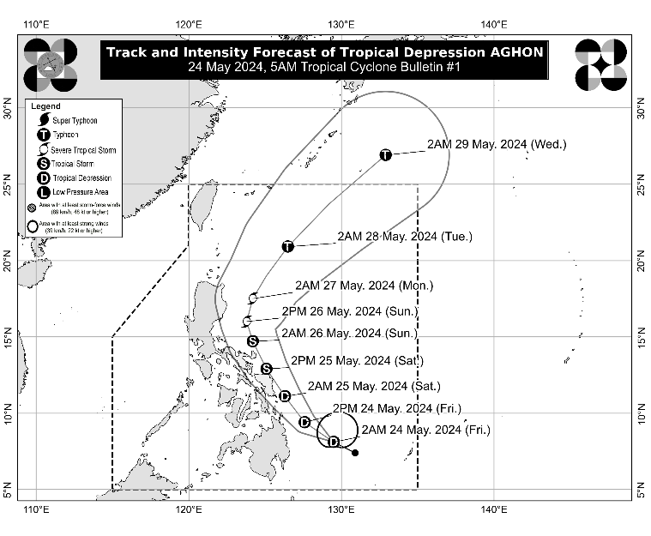
The center of Tropical Depression AGHON was estimated based on all available data at 340 km East of Hinatuan, Surigao del Sur (8.6°N, 129.4°E)
Intensity
Maximum sustained winds of 45 km/h near the center, gustiness of up to 55 km/h, and central pressure of 1004 hPa
Present Movement
West Northwestward at 30 km/h
Extent of Tropical Cyclone Winds
Strong winds extend outwards up to 220 km from the center
TRACK AND INTENSITY FORECAST
Date and Time | Center Position |  |  |  | Intensity |  | Movement dir. and speed (km/h)
 | Lat.  (°N) | Lon.  (°E) | Location |  | MSW  (km/h) | Cat.
12-Hour Forecast  2:00 PM  24 May 2024 | 9.4 | 127.6 | 235 km East of Surigao City, Surigao del Norte |  | 45 | TD | NW 20
24-Hour Forecast  2:00 AM  25 May 2024 | 11.1 | 126.3 | 60 km East of Guiuan, Eastern Samar |  | 55 | TD | NW 20
36-Hour Forecast  2:00 PM  25 May 2024 | 12.9 | 125.1 | Over the coastal waters of Laoang, Northern Samar |  | 65 | TS | NNW 20
48-Hour Forecast  2:00 AM  26 May 2024 | 14.7 | 124.2 | 125 km North of Virac, Catanduanes or 270 km East of Infanta, Quezon |  | 75 | TS | NNW 20
60-Hour Forecast  2:00 PM  26 May 2024 | 16.0 | 123.8 | 180 km East of Casiguran, Aurora |  | 95 | STS | NNW 15
72-Hour Forecast  2:00 AM  27 May 2024 | 17.5 | 124.2 | 260 km East of Tuguegarao City, Cagayan |  | 110 | STS | NNE 15
96-Hour Forecast  2:00 AM  28 May 2024 | 20.9 | 126.5 | 475 km East of Basco, Batanes |  | 120 | TY | NNE 20
120-Hour Forecast  2:00 AM  29 May 2024 | 26.9 | 132.9 | 1,315 km East Northeast of Extreme Northern Luzon (OUTSIDE PAR) |  | 120 | TY | NE 40

TROPICAL CYCLONE WIND SIGNALS (TCWS) IN EFFECT
TCWS No. | Luzon | Visayas | Mindanao
1  Wind threat: Strong winds | - | Eastern Samar | Dinagat Islands, Siargao Islands, and Bucas Grande Islands
Warning lead time: 36 hours
Range of wind speeds: 39 to 61 km/h (Beaufort 6 to 7)
Potential impacts of winds: Minimal to minor threat to life and property

HAZARDS AFFECTING LAND AREAS
Heavy Rainfall Outlook

Forecast accumulated rainfall: Today
- 50-100 mm: Surigao del Norte, Dinagat Islands, the northern portion of Surigao del Sur, the eastern portion of Southern Leyte, and the southern portion of Eastern Samar.

Forecast accumulated rainfall: Tomorrow
- 100-200 mm: Eastern Samar, Northern Samar, Camarines Sur, Catanduanes, Albay, and Sorsogon
- 50-100 mm: Dinagat Islands and the rest of Bicol and Eastern Visayas

Forecast accumulated rainfall: Sunday
- 50-100 mm: Catanduanes, Camarines Norte, and Camarines Sur

Forecast rainfall are generally higher in elevated or mountainous areas. Under these conditions, flooding and rain-induced landslides are possible especially in areas that are highly or very highly susceptible to these hazards as identified in hazard maps and in localities that experienced considerable amounts of rainfall for the past several days.
Severe Winds

The wind signals warn the public of the general wind threat over an area due to the tropical cyclone. Local winds may be slightly stronger/enhanced in coastal and upland/mountainous areas exposed to winds. Winds are less strong in areas sheltered from the prevailing wind direction.

- Minimal to minor impacts from strong winds are possible within any of the areas under Wind Signal No. 1.

Additional areas in Eastern Visayas and Caraga Region may be placed under Wind Signal No.1 in the next bulletin. The highest possible Wind Signal that may be hoisted during the passage of AGHON is Wind Signal No. 2.

HAZARDS AFFECTING COASTAL WATERS
Today, AGHON will bring moderate to rough seas (1.5 to 3.0 m) over the coastal waters along the northern and eastern seaboards of Eastern Visayas and the eastern seaboard of Caraga Region. Mariners of motor bancas and similarly-sized vessels are advised to take precautionary measures while venturing out to sea and, if possible, avoid navigating in these conditions, especially if inexperienced or operating ill-equipped vessels.

TRACK AND INTENSITY OUTLOOK
- AGHON is forecast to move generally northwestward or north northwestward from today until tomorrow while slowly intensifying. On the track forecast, AGHON is forecast to make a close approach or make landfall in the vicinity of Eastern Samar tomorrow morning as a tropical depression. Afterwards, AGHON will pass north northwestward over Eastern Visayas, then emerge over the waters off the east coast of Bicol Region tomorrow afternoon or evening as a tropical storm. On Sunday, AGHON will begin recurving generally northeastward or north northeastward over the waters east of Luzon while starting to continuously intensify. Current forecast scenario shows intensification into a severe tropical storm by mid Sunday and into a typhoon by Tuesday.
- Considering the trend in the westward shift in the track forecast of AGHON and the forecast probability cone, a slightly earlier landfall over Eastern Samar and a direct passage in the vicinity of Bicol Region is not ruled out at this time.

Considering these developments, the public and disaster risk reduction and management offices concerned are advised to take all necessary measures to protect life and property. Persons living in areas identified to be highly or very highly susceptible to these hazards are advised to follow evacuation and other instructions from local officials. For heavy rainfall warnings, thunderstorm/rainfall advisories, and other severe weather information specific to your area, please monitor products issued by your local PAGASA Regional Services Division.

The next tropical cyclone bulletin will be issued at 11:00 AM today.

DOST-PAGASA

