“AGHON” SLIGHTLY INTENSIFIED AND MADE LANDFALL OVER PATNANUNGAN, QUEZON
Location of Center (7:00 PM) |  |  |  | 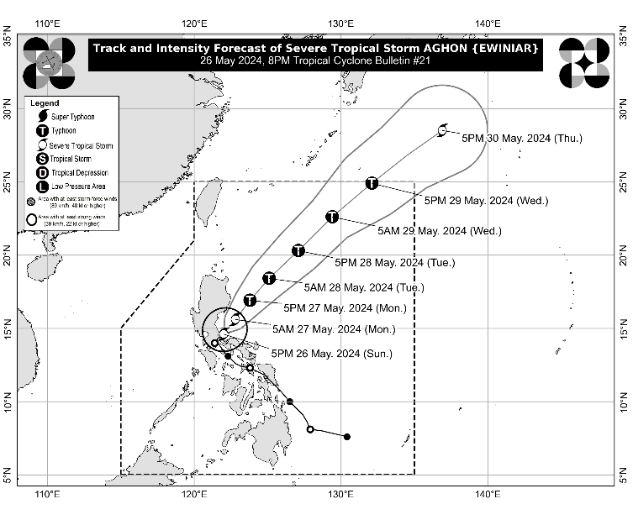
The center of Severe Tropical Storm AGHON was estimated based on all available data including those from Baler, Tagaytay and Daet Doppler Weather Radars in the vicinity of Patnanungan, Quezon (14.8°N, 122.2°E)
Intensity
Maximum sustained winds of 100 km/h near the center, gustiness of up to 150 km/h, and central pressure of 990 hPa
Present Movement
Northeastward Slowly
Extent of Tropical Cyclone Winds
Strong to storm-force winds extend outwards up to 200 km from the center
TRACK AND INTENSITY FORECAST
Date and Time | Center Position |  |  |  | Intensity |  | Movement dir. and speed (km/h)
 | Lat.  (°N) | Lon.  (°E) | Location |  | MSW  (km/h) | Cat.
12-Hour Forecast  5:00 AM  27 May 2024 | 15.6 | 122.8 | 105 km East Southeast of Baler, Aurora |  | 110 | STS | NE 20
24-Hour Forecast  5:00 PM  27 May 2024 | 16.9 | 123.8 | 140 km East Northeast of Casiguran, Aurora |  | 120 | TY | NE 15
36-Hour Forecast  5:00 AM  28 May 2024 | 18.4 | 125.1 | 300 km East of Tuguegarao City, Cagayan |  | 120 | TY | NE 20
48-Hour Forecast  5:00 PM  28 May 2024 | 20.3 | 127.1 | 490 km East of Basco, Batanes |  | 130 | TY | NE 25
60-Hour Forecast  5:00 AM  29 May 2024 | 22.6 | 129.4 | 705 km East Northeast of Basco, Batanes |  | 130 | TY | NE 30
72-Hour Forecast  5:00 PM  29 May 2024 | 24.9 | 132.1 | 1,060 km East Northeast of Extreme Northern Luzon |  | 120 | TY | NE 30
96-Hour Forecast  5:00 PM  30 May 2024 | 28.5 | 136.9 | 1,615 km East Northeast of Extreme Northern Luzon (OUTSIDE PAR) |  | 100 | STS | NE 25

TROPICAL CYCLONE WIND SIGNALS (TCWS) IN EFFECT
TCWS No. | Luzon | Visayas | Mindanao
3  Wind threat: Storm-force winds | Polillo Islands
Warning lead time: 18 hours
Range of wind speeds: 89 to 117 km/h (Beaufort 10 to 11)
Potential impacts of winds: Moderate to significant threat to life and property
2  Wind threat: Gale-force winds | Aurora, the northern and central portions of Quezon (Alabat, Perez, Quezon, Gumaca, Lopez, Macalelon, General Luna, Unisan, Pitogo, Plaridel, Agdangan, Padre Burgos, Atimonan, General Nakar, Sampaloc, Pagbilao, Calauag, Lucban, City of Tayabas, Lucena City, Tiaong, Candelaria, Sariaya, Dolores, San Antonio, Infanta, Real, Mauban), Laguna, the eastern portion of Batangas (City of Tanauan, San Jose, Lipa City, Mataasnakahoy, Balete, Malvar, Santo Tomas, Cuenca, Ibaan, Padre Garcia, Rosario, San Juan, Taysan), the eastern portion of Rizal (Jala-Jala, Pililla, Tanay, Cardona, Binangonan, Morong, Baras, Rodriguez, City of Antipolo, Teresa), and the northern portion of Camarines Norte (Santa Elena, Capalonga) | - | -
Warning lead time: 24 hours
Range of wind speeds: 62 to 88 km/h (Beaufort 8 to 9)
Potential impacts of winds: Minor to moderate threat to life and property
1  Wind threat: Strong winds | The eastern portion of Isabela (Divilacan, San Mariano, San Guillermo, Jones, Echague, San Agustin, Ilagan City, Benito Soliven, City of Cauayan, Maconacon, Angadanan, Naguilian, Palanan, Dinapigue), the eastern portion of Quirino (Maddela, Nagtipunan, Aglipay), the eastern portion of Nueva Vizcaya (Alfonso Castaneda, Dupax del Sur, Dupax del Norte), the eastern portion of Nueva Ecija (General Tinio, Gabaldon, Bongabon, Pantabangan, Rizal, General Mamerto Natividad, Laur, Palayan City, Peñaranda, San Leonardo, City of Gapan, Cabanatuan City, Santa Rosa, San Isidro, Cabiao, San Antonio, Jaen, Llanera), the eastern portion of Pampanga (Candaba, San Luis, San Simon, Apalit, Santa Ana, Arayat, Mexico, Sasmuan, Macabebe, Masantol, Santo Tomas, Minalin, City of San Fernando, Bacolor), the southeastern portion of Bataan (Pilar, Orion, Limay, Mariveles), Bulacan, Metro Manila, the rest of Rizal, Cavite, the rest of Batangas, the rest of Quezon, the northeastern portion of Oriental Mindoro (Pinamalayan, Pola, Naujan, Victoria, Socorro, City of Calapan, Baco, San Teodoro, Puerto Galera), Marinduque, the rest of Camarines Norte, and the northern portion of Camarines Sur (Siruma, Tinambac, Milaor, Cabusao, Camaligan, Pili, Sipocot, Pamplona, Ragay, San Fernando, Magarao, Minalabac, Del Gallego, Libmanan, Naga City, Calabanga, Bombon, Canaman, Pasacao, Gainza, Lupi) | - | -
Warning lead time: 36 hours
Range of wind speeds: 39 to 61 km/h (Beaufort 6 to 7)
Potential impacts of winds: Minimal to minor threat to life and property

HAZARDS AFFECTING LAND AREAS
Heavy Rainfall Outlook

Forecast accumulated rainfall: Tonight to tomorrow evening
- > 200 mm: Quezon
- 100-200 mm: Aurora, the eastern portion of Bulacan, Rizal, Laguna, Metro Manila, and Camarines Norte
- 50-100 mm: The eastern portion of Isabela, Nueva Ecija, the rest of Bulacan, the eastern portion of Pampanga, Cavite, Batangas, Oriental Mindoro, Occidental Mindoro, Romblon, Burias Island, the western portion of Camarines Sur, Cuyo Islands, Aklan, and Antique.

Forecast rainfall are generally higher in elevated or mountainous areas. Under these conditions, flooding and rain-induced landslides are likely especially in areas that are highly or very highly susceptible to these hazards as identified in hazard maps and in localities that experienced considerable amounts of rainfall for the past several days
Severe Winds

The wind signals warn the public of the general wind threat over an area due to the tropical cyclone. Local winds may be slightly stronger/enhanced in coastal and upland/mountainous areas exposed to winds. Winds are less strong in areas sheltered from the prevailing wind direction.

- Moderate to significant impacts from storm-force winds are possible within any of the areas where Wind Signal No. 3 is hoisted.
- Minor to moderate impacts from strong winds are possible within any of the localities where Wind Signal No. 2 is hoisted.
- Minimal to minor impacts from strong winds are possible within any of the areas under Wind Signal No. 1.

Coastal Inundation

Within the next 24 hours, there is a minimal to moderate risk of storm surge over the exposed and low-lying coastal areas of Cagayan, Isabela, Central Luzon, Metro Manila, CALABARZON, Mindoro Provinces, Marinduque, Romblon, Camarines Norte, Camarines Sur, and Burias Island. For more information, refer to Storm Surge Warning No. 2 issued at 2:00 PM today.

HAZARDS AFFECTING COASTAL WATERS
- Under the influence of AGHON, a Gale Warning is hoisted over the coastal waters of Aurora, Quezon, and Marinduque, and the southern coastal waters of Batangas, and the northern coastal waters of Camarines Norte. Sea travel is risky for small seacrafts, including all motorbancas of any type of tonnage. For more information, refer to Gale Warning No. 3 issued at 5:00 PM today.
- Outside the Gale Warning areas, AGHON will bring moderate to rough seas (1.5 to 3.5 m) over the coastal waters along the northern and eastern seaboards of Luzon and the seaboard of Bicol Region. Mariners of motor bancas and similarly-sized vessels are advised to take precautionary measures while venturing out to sea and, if possible, avoid navigating in these conditions, especially if inexperienced or operating ill-equipped vessels.

TRACK AND INTENSITY OUTLOOK
- AGHON will continue to move northeastward towards the Philippine Sea. The possibility of intensifying into a typhoon while over the next 12 hours is not ruled out.
- From tomorrow through the remainder of the forecast period, AGHON will gradually accelerate northeastward while intensifying. AGHON is forecast to reach Typhoon category by tomorrow afternoon and may exit the PAR region on Wednesday.

Considering these developments, the public and disaster risk reduction and management offices concerned are advised to take all necessary measures to protect life and property. Persons living in areas identified to be highly or very highly susceptible to these hazards are advised to follow evacuation and other instructions from local officials. For heavy rainfall warnings, thunderstorm/rainfall advisories, and other severe weather information specific to your area, please monitor products issued by your local PAGASA Regional Services Division.

The next tropical cyclone bulletin will be issued at 11:00 PM today.

DOST-PAGASA

