“AGHON” HAS RAPIDLY INTENSIFIED INTO A TYPHOON OVER THE
COASTAL WATERS OF BURDEOS, QUEZON.
Location of Center (10:00 PM) |  |  |  | 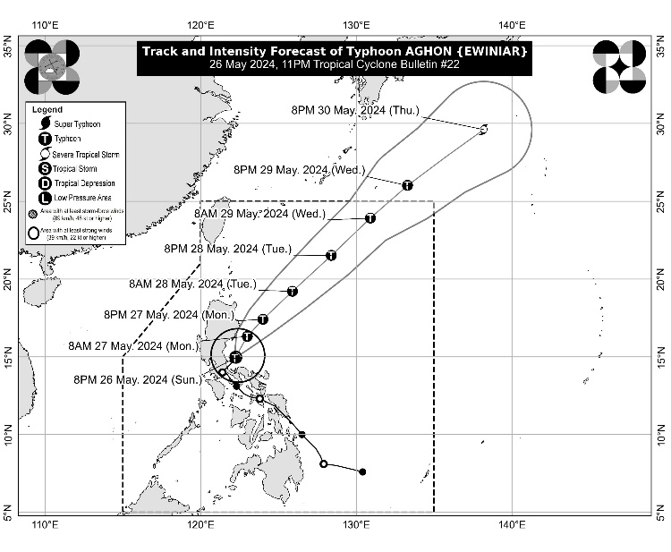
The center of the eye of Typhoon AGHON was estimated based on all available data including those from Baler, Tagaytay, and Daet Doppler Weather Radars over the coastal waters of Burdeos, Quezon (15.1°N, 122.3°E)
Intensity
Maximum sustained winds of 120 km/h near the center, gustiness of up to 180 km/h, and central pressure of 980 hPa
Present Movement
Northeastward at 15 km/h
Extent of Tropical Cyclone Winds
Strong to typhoon-force winds extend outwards up to 220 km from the center
TRACK AND INTENSITY FORECAST
Date and Time | Center Position |  |  |  | Intensity |  | Movement dir. and speed (km/h)
 | Lat.  (°N) | Lon.  (°E) | Location |  | MSW  (km/h) | Cat.
12-Hour Forecast  8:00 AM  27 May 2024 | 16.3 | 123.0 | 95 km East of Casiguran, Aurora |  | 130 | TY | NNE 15
24-Hour Forecast  8:00 PM  27 May 2024 | 17.4 | 124.0 | 240 km East of Tuguegarao City, Cagayan |  | 140 | TY | NE 15
36-Hour Forecast  8:00 AM  28 May 2024 | 19.2 | 125.9 | 465 km East of Calayan, Cagayan |  | 150 | TY | NE 25
48-Hour Forecast  8:00 PM  28 May 2024 | 21.5 | 128.4 | 685 km East of Itbayat, Batanes |  | 150 | TY | NE 30
60-Hour Forecast  8:00 AM  29 May 2024 | 23.9 | 130.9 | 995 km East Northeast of Extreme Northern Luzon |  | 140 | TY | NE 30
72-Hour Forecast  8:00 PM  29 May 2024 | 26.0 | 133.3 | 1,305 km East Northeast of Extreme Northern Luzon (OUTSIDE PAR) |  | 130 | TY | NE 30
96-Hour Forecast  8:00 PM  30 May 2024 | 29.6 | 138.2 | 1,915 km Northeast of Extreme Northern Luzon (OUTSIDE PAR) |  | 100 | STS | NE 25

TROPICAL CYCLONE WIND SIGNALS (TCWS) IN EFFECT
TCWS No. | Luzon | Visayas | Mindanao
3  Wind threat: Storm-force winds | Polillo Islands | - | -
Warning lead time: 18 hours
Range of wind speeds: 89 to 117 km/h (Beaufort 10 to 11)
Potential impacts of winds: Moderate to significant threat to life and property
2  Wind threat: Gale-force winds | Aurora, the northern and central portions of Quezon (Real, General Nakar, Infanta, Mauban, Calauag, Perez, Alabat, Quezon), and the northern portion of Camarines Norte (Santa Elena, Capalonga) | - | -
Warning lead time: 24 hours
Range of wind speeds: 62 to 88 km/h (Beaufort 8 to 9)
Potential impacts of winds: Minor to moderate threat to life and property
1  Wind threat: Strong winds | The eastern portion of Isabela (Divilacan, San Mariano, San Guillermo, Jones, Echague, San Agustin, Ilagan City, Benito Soliven, City of Cauayan, Maconacon, Angadanan, Naguilian, Palanan, Dinapigue), the eastern portion of Quirino (Maddela, Nagtipunan, Aglipay), the eastern portion of Nueva Vizcaya (Alfonso Castaneda, Dupax del Sur, Dupax del Norte), the eastern portion of Nueva Ecija (General Tinio, Gabaldon, Bongabon, Pantabangan, Rizal, General Mamerto Natividad, Laur, Palayan City, Peñaranda, San Leonardo, City of Gapan, Cabanatuan City, Santa Rosa, San Isidro, Cabiao, San Antonio, Jaen, Llanera), the eastern portion of Pampanga (Candaba, San Luis, San Simon, Apalit, Santa Ana, Arayat, Mexico, Sasmuan, Macabebe, Masantol, Santo Tomas, Minalin, City of San Fernando, Bacolor), the southeastern portion of Bataan (Pilar, Orion, Limay, Mariveles), Bulacan, Metro Manila, Rizal, Cavite, Laguna, Batangas, the rest of Quezon, Marinduque, the rest of Camarines Norte, and the northern portion of Camarines Sur (Siruma, Tinambac, Milaor, Cabusao, Camaligan, Pili, Sipocot, Pamplona, Ragay, San Fernando, Magarao, Minalabac, Del Gallego, Libmanan, Naga City, Calabanga, Bombon, Canaman, Pasacao, Gainza, Lupi) | - | -
Warning lead time: 36 hours
Range of wind speeds: 39 to 61 km/h (Beaufort 6 to 7)
Potential impacts of winds: Minimal to minor threat to life and property

HAZARDS AFFECTING LAND AREAS
Heavy Rainfall Outlook

Forecast accumulated rainfall: Tonight to tomorrow evening
- 100-200 mm: Polillo Islands
- 50-100 mm: Aurora, Rizal, Laguna, Metro Manila, Camarines Norte, Occidental Mindoro, Oriental Mindoro, Calamian and Cuyo Islands, Antique, Aklan, the rest of Quezon, and the eastern portions of Isabela, Nueva Ecija, and Bulacan.

Forecast rainfall are generally higher in elevated or mountainous areas. Under these conditions, flooding and rain-induced landslides are likely especially in areas that are highly or very highly susceptible to these hazards as identified in hazard maps and in localities that experienced considerable amounts of rainfall for the past several days
Severe Winds

The wind signals warn the public of the general wind threat over an area due to the tropical cyclone. Local winds may be slightly stronger/enhanced in coastal and upland/mountainous areas exposed to winds. Winds are less strong in areas sheltered from the prevailing wind direction.

- Moderate to significant impacts from storm-force winds are possible within any of the areas where Wind Signal No. 3 is hoisted.
- Minor to moderate impacts from gale-force winds are possible within any of the localities where Wind Signal No. 2 is hoisted.
- Minimal to minor impacts from strong winds are possible within any of the areas under Wind Signal No. 1.
Coastal Inundation

Within the next 24 hours, there is a minimal to moderate risk of storm surge over the exposed and low-lying coastal areas of Cagayan (southern coast), Isabela, Aurora, Quezon, Marinduque and Camarines Norte. For more information, refer to Storm Surge Warning No. 3 issued at 8:00 PM today.

HAZARDS AFFECTING COASTAL WATERS
- Under the influence of AGHON, a Gale Warning is hoisted over the coastal waters of Aurora, Quezon, and Marinduque, and the southern coastal waters of Batangas, and the northern coastal waters of Camarines Norte. Sea travel is risky for small seacrafts, including all motorbancas of any type of tonnage. For more information, refer to Gale Warning No. 3 issued at 5:00 PM today.
- Outside the Gale Warning areas, AGHON will bring moderate to rough seas (1.5 to 3.5 m) over the coastal waters along the northern and eastern seaboards of Luzon and the seaboard of Bicol Region. Mariners of motor bancas and similarly-sized vessels are advised to take precautionary measures while venturing out to sea and, if possible, avoid navigating in these conditions, especially if inexperienced or operating ill-equipped vessels.

TRACK AND INTENSITY OUTLOOK
- AGHON will continue intensifying over the next two days as it accelerates northeastward over the Philippine Sea. On the track forecast, the typhoon will exit the Philippine Area of Responsibility (PAR) on Wednesday afternoon or evening.
- Outside the PAR region, AGHON will continue moving northeastward towards the sea south of mainland Japan. A weakening trend may also begin by Thursday.

Considering these developments, the public and disaster risk reduction and management offices concerned are advised to take all necessary measures to protect life and property. Persons living in areas identified to be highly or very highly susceptible to these hazards are advised to follow evacuation and other instructions from local officials. For heavy rainfall warnings, thunderstorm/rainfall advisories, and other severe weather information specific to your area, please monitor products issued by your local PAGASA Regional Services Division.

The next tropical cyclone bulletin will be issued at 2:00 AM tomorrow.

DOST-PAGASA

