“AGHON” SLIGHTLY INTENSIFIES OVER THE PHILIPPINE SEA EAST OF AURORA.
Location of Center (4:00 AM) |  |  |  | 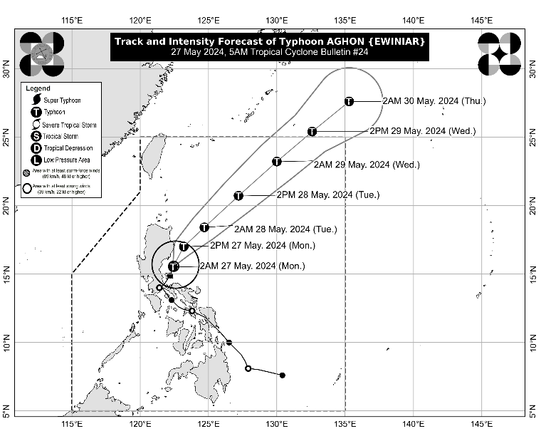
The center of the eye of Typhoon AGHON was estimated based on all available data including those from Baler, Tagaytay, and Daet Doppler Weather Radars at 105 km East of Baler, Aurora (15.6°N, 122.6°E)
Intensity
Maximum sustained winds of 140 km/h near the center, gustiness of up to 170 km/h, and central pressure of 965 hPa
Present Movement
North Northeastward at 10 km/h
Extent of Tropical Cyclone Winds
Strong to typhoon-force winds extend outwards up to 220 km from the center
TRACK AND INTENSITY FORECAST
Date and Time | Center Position |  |  |  | Intensity |  | Movement dir. and speed (km/h)
 | Lat.  (°N) | Lon.  (°E) | Location |  | MSW  (km/h) | Cat.
12-Hour Forecast  2:00 PM  27 May 2024 | 17.0 | 123.2 | 170 km East Southeast of Tuguegarao City, Cagayan |  | 150 | TY | NNE 15
24-Hour Forecast  2:00 AM  28 May 2024 | 18.4 | 124.7 | 325 km East of Aparri, Cagayan |  | 155 | TY | NE 20
36-Hour Forecast  2:00 PM  28 May 2024 | 20.7 | 127.2 | 560 km East of Itbayat, Batanes |  | 155 | TY | NE 30
48-Hour Forecast  2:00 AM  29 May 2024 | 23.2 | 130.0 | 885 km East Northeast of Extreme Northern Luzon |  | 155 | TY | NE 35
60-Hour Forecast  2:00 PM  29 May 2024 | 25.4 | 132.6 | 1,215 km East Northeast of Extreme Northern Luzon (OUTSIDE PAR) |  | 150 | TY | NE 30
72-Hour Forecast  2:00 AM  30 May 2024 | 27.6 | 135.3 | 1,560 km East Northeast of Extreme Northern Luzon (OUTSIDE PAR) |  | 140 | TY | NE 30

TROPICAL CYCLONE WIND SIGNALS (TCWS) IN EFFECT
TCWS No. | Luzon | Visayas | Mindanao
2  Wind threat: Gale-force winds | The southeastern portion of Isabela (Dinapigue, Palanan), the northern portion of Aurora (Baler, Dipaculao, Dinalungan, Dilasag, Casiguran), and Polillo Islands | - | -
Warning lead time: 24 hours
Range of wind speeds: 62 to 88 km/h (Beaufort 8 to 9)
Potential impacts of winds: Minor to moderate threat to life and property
1  Wind threat: Strong winds | The northeastern and southern portion of Isabela (Divilacan, San Mariano, San Guillermo, Jones, Echague, San Agustin, Ilagan City, Benito Soliven, City of Cauayan, Maconacon, Angadanan, Naguilian), the eastern portion of Quirino (Maddela, Nagtipunan, Aglipay), the eastern portion of Nueva Vizcaya (Alfonso Castaneda, Dupax del Sur, Dupax del Norte), the rest of Aurora, eastern portion of Nueva Ecija (General Tinio, Gabaldon, Bongabon, Pantabangan, Rizal, General Mamerto Natividad, Laur, Palayan City, Peñaranda, San Leonardo, City of Gapan, Cabanatuan City, Santa Rosa, Llanera), the eastern portion of Bulacan (San Miguel, San Ildefonso, Doña Remedios Trinidad, Norzagaray), Rizal, the northeastern portion of Laguna (Pakil, Mabitac, Pangil, Famy, Siniloan, Santa Maria, Paete, Kalayaan, Lumban), the northern and central portions of Quezon (General Nakar, Infanta, Real, Mauban, Perez, Alabat, Quezon, Calauag, Tagkawayan, Guinayangan, Lopez, Atimonan, Gumaca, Plaridel), and the western portion of Camarines Norte (Santa Elena, Vinzons, Labo, Capalonga, Paracale, Talisay, Jose Panganiban, San Vicente, Daet) including Calaguas Islands | - | -
Warning lead time: 36 hours
Range of wind speeds: 39 to 61 km/h (Beaufort 6 to 7)
Potential impacts of winds: Minimal to minor threat to life and property

HAZARDS AFFECTING LAND AREAS
Heavy Rainfall Outlook

Forecast accumulated rainfall: Today
- 50-100 mm: The eastern portion of Isabela and the northern portion of Aurora

Forecast rainfall are generally higher in elevated or mountainous areas. Under these conditions, flooding and rain-induced landslides are possible especially in areas that are highly or very highly susceptible to these hazards as identified in hazard maps and in localities that experienced considerable amounts of rainfall for the past several days
Severe Winds

The wind signals warn the public of the general wind threat over an area due to the tropical cyclone. Local winds may be slightly stronger/enhanced in coastal and upland/mountainous areas exposed to winds. Winds are less strong in areas sheltered from the prevailing wind direction.

- Minor to moderate impacts from gale-force winds are possible within any of the localities where Wind Signal No. 2 is hoisted.
- Minimal to minor impacts from strong winds are possible within any of the areas under Wind Signal No. 1.
Coastal Inundation

Within the next 24 hours, there is a minimal to moderate risk of storm surge over the exposed and low-lying coastal areas of Cagayan, Isabela, Aurora, and Polillo Islands. For more information, refer to Storm Surge Warning No. 4 issued at 2:00 AM today.

HAZARDS AFFECTING COASTAL WATERS
- Under the influence of AGHON, a Gale Warning is hoisted over the coastal waters of Cagayan (southern portion), Isabela, Aurora, and the northern coastal waters of Quezon including Polillo Islands. Sea travel is risky for small seacrafts, including all motorbancas of any type of tonnage. For more information, refer to Gale Warning No. 4 issued at 5:00 AM today.
- Outside the Gale Warning areas, AGHON will bring moderate to rough seas (1.5 to 3.0 m) over the eastern coastal waters of Cagayan and the northern coastal waters of Bicol Region. Mariners of motor bancas and similarly-sized vessels are advised to take precautionary measures while venturing out to sea and, if possible, avoid navigating in these conditions, especially if inexperienced or operating ill-equipped vessels.

TRACK AND INTENSITY OUTLOOK
- On the track forecast, Typhoon AGHON will move generally northeastward over the Philippine Sea for the entirety of the forecast period. It may exit the Philippine Area of Responsibility (PAR) on Wednesday afternoon or evening as a typhoon.
- AGHON will continue to intensify over the next two days as it moves northeastward over the Philippine Sea. A weakening trend may begin on mid or late Wednesday as the typhoon begins interacting with the mid-latitude environment and undergo post-tropical transition.

Considering these developments, the public and disaster risk reduction and management offices concerned are advised to take all necessary measures to protect life and property. Persons living in areas identified to be highly or very highly susceptible to these hazards are advised to follow evacuation and other instructions from local officials. For heavy rainfall warnings, thunderstorm/rainfall advisories, and other severe weather information specific to your area, please monitor products issued by your local PAGASA Regional Services Division.

The next tropical cyclone bulletin will be issued at 8:00 AM today.

DOST-PAGASA

