TYPHOON “AGHON” IS NOW OUTSIDE THE PHILIPPINE AREA OF RESPONSIBILITY
Location of Center (4:00 PM) |  |  |  | 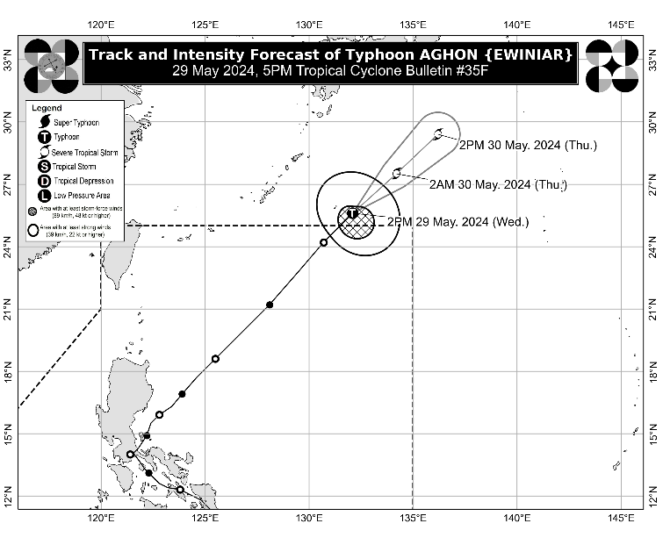
The center of Typhoon AGHON was estimated based on all available data at 1,225 km East Northeast of Extreme Northern Luzon (26.0°N, 132.4°E)
Intensity
Maximum sustained winds of 120 km/h near the center, gustiness of up to 150 km/h, and central pressure of 975 hPa
Present Movement
Northeastward at 35 km/h
Extent of Tropical Cyclone Winds
Strong to typhoon-force winds extend outwards up to 260 km from the center
TRACK AND INTENSITY FORECAST
Date and Time | Center Position |  |  |  | Intensity |  | Movement dir. and speed (km/h)
 | Lat.  (°N) | Lon.  (°E) | Location |  | MSW  (km/h) | Cat.
12-Hour Forecast  2:00 AM  30 May 2024 | 27.5 | 134.2 | 1,460 km East Northeast of Extreme Northern Luzon (OUTSIDE PAR) |  | 110 | STS | NE 25
24-Hour Forecast  2:00 PM  30 May 2024 | 29.4 | 136.2 | 1,735 km Northeast of Extreme Northern Luzon (OUTSIDE PAR) |  | 100 | STS | NE 25

TROPICAL CYCLONE WIND SIGNALS (TCWS) IN EFFECT
No Wind Signal hoisted at this time.

HAZARDS AFFECTING LAND AREAS
Heavy Rainfall Outlook

- Typhoon AGHON is unlikely to directly bring significant amount of rainfall within the next three days.
- The Southwesterly Windflow partly influenced by AGHON will bring moderate to heavy rains over the western portions of Northern Luzon, Central Luzon and MIMAROPA until tomorrow. For more information, refer to Weather Advisory No. 6 issued at 11:00 AM today.
Severe Winds

The Southwesterly Windflow partly influenced by AGHON will bring occasional gusty conditions in the next three days over the following areas, especially in coastal and upland/mountainous localities exposed to winds:

- Today: Batanes, Ilocos Region, Zambales, Bataan, northern Aurora, southern mainland Quezon, Polillo Islands, Palawan, Lubang Islands, Romblon, Marinduque, and Camarines Norte
- Tomorrow: Batanes, Ilocos Region, Zambales, Bataan, Lubang Islands, and Kalayaan Islands.
- Friday: Batanes and Ilocos Region

HAZARDS AFFECTING COASTAL WATERS
The Southwesterly Windflow partly influenced by AGHON and the Frontal System will bring moderate to rough seas (1.0 to 3.0 m) over the coastal waters of Batanes. Mariners of motorbancas and similarly-sized vessels are advised to take precautionary measures while venturing out to sea and, if possible, avoid navigating in these conditions, especially if inexperienced or operating ill-equipped vessels.

TRACK AND INTENSITY OUTLOOK
- On the track forecast, AGHON will move generally northeastward over the sea area south of Japan.
- AGHON will continue to gradually weaken due to increasingly hostile environmental conditions as it begins to interact with the mid-latitude environment and undergo post-tropical transition.

Considering these developments, the public and disaster risk reduction and management offices concerned are advised to take all necessary measures to protect life and property. Persons living in areas identified to be highly or very highly susceptible to these hazards are advised to follow evacuation and other instructions from local officials. For heavy rainfall warnings, thunderstorm/rainfall advisories, and other severe weather information specific to your area, please monitor products issued by your local PAGASA Regional Services Division.

Unless re-entry occurs, this is the final bulletin for this tropical cyclone. Succeeding updates will be incorporated in the 24-Hour Public Weather Forecast issued twice daily at 4:00 AM and 4:00 PM.

DOST-PAGASA

