TROPICAL DEPRESSION “AGHON” SLIGHTLY INTENSIFIES AS IT MOVES WESTWARD
Location of Center (1:00 PM) |  |  |  | 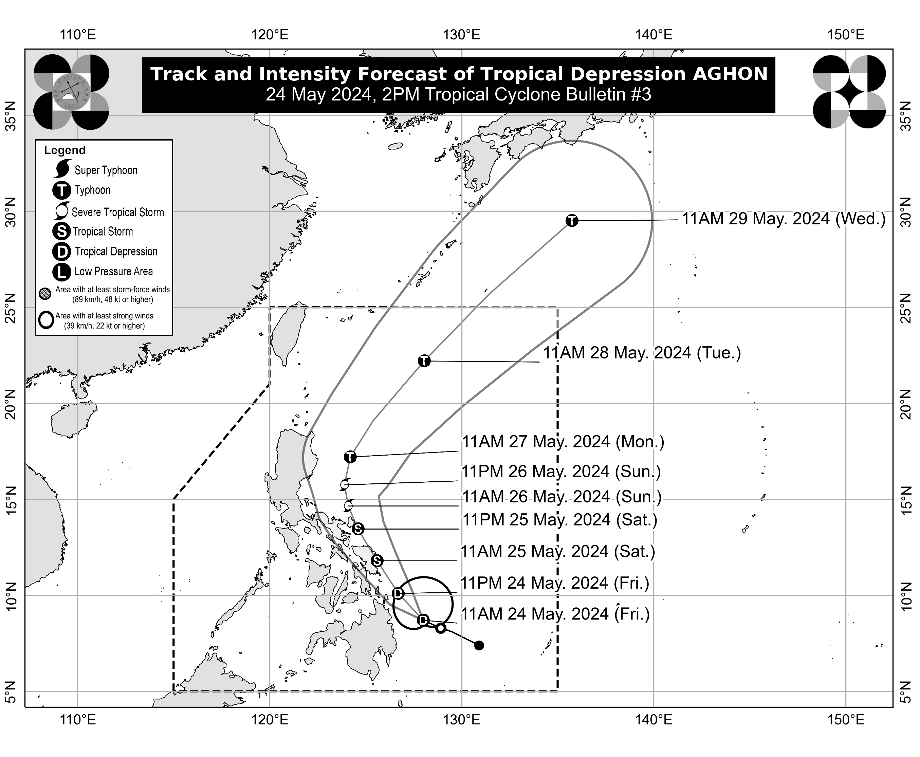
The center of Tropical Depression AGHON was estimated based on all available data at 135 km East Northeast of Hinatuan, Surigao del Sur (8.8°N, 127.5°E)
Intensity
Maximum sustained winds of 55 km/h near the center, gustiness of up to 70 km/h, and central pressure of 1006 hPa
Present Movement
West Northwestward at 25 km/h
Extent of Tropical Cyclone Winds
Strong winds extend outwards up to 220 km from the center
TRACK AND INTENSITY FORECAST
Date and Time | Center Position |  |  |  | Intensity |  | Movement dir. and speed (km/h)
 | Lat.  (°N) | Lon.  (°E) | Location |  | MSW  (km/h) | Cat.
12-Hour Forecast  2:00 AM  25 May 2024 | 10.1 | 126.7 | 135 km East Northeast of Surigao City, Surigao del Norte |  | 55 | TD | NW 20
24-Hour Forecast  2:00 PM  25 May 2024 | 11.8 | 125.6 | In the coastal waters of Borongan City, Eastern Samar |  | 65 | TS | NNW 20
36-Hour Forecast  2:00 AM  26 May 2024 | 13.5 | 124.6 | In the coastal waters of Virac, Catanduanes |  | 85 | TS | NNW 20
48-Hour Forecast  2:00 PM  26 May 2024 | 14.7 | 124.1 | 260 km East of Infanta, Quezon |  | 95 | STS | NNW 10
60-Hour Forecast  2:00 AM  27 May 2024 | 15.8 | 123.9 | 195 km East Southeast of Casiguran, Aurora |  | 110 | STS | N 10
72-Hour Forecast  2:00 PM  27 May 2024 | 17.2 | 124.2 | 265 km East of Tuguegarao City, Cagayan |  | 120 | TY | N 15
96-Hour Forecast  2:00 PM  28 May 2024 | 22.2 | 128.1 | 665 km East Northeast of Basco, Batanes |  | 130 | TY | NE 30
120-Hour Forecast  2:00 PM  29 May 2024 | 29.5 | 135.8 | 1,705 km Northeast of Extreme Northern Luzon (OUTSIDE PAR) |  | 130 | TY | NE 45

TROPICAL CYCLONE WIND SIGNALS (TCWS) IN EFFECT
TCWS No. | Luzon | Visayas | Mindanao
1  Wind threat: Strong winds | Sorsogon, Albay, Catanduanes, Camarines Sur, Camarines Norte (San Vicente, San Lorenzo Ruiz, Basud, Daet, Talisay, Mercedes), and Masbate including Ticao Island, Burias Island | Eastern Samar, Samar, Northern Samar, Leyte, Southern Leyte, Biliran, and Camotes Islands | Dinagat Islands, Surigao del Norte including Siargao and Bucas Grande Islands, Surigao del Sur, Agusan del Sur (Sibagat, City of Bayugan, Prosperidad, San Francisco, Rosario, Bunawan, Trento), and Agusan del Norte
Warning lead time: 36 hours
Range of wind speeds: 39 to 61 km/h (Beaufort 6 to 7)
Potential impacts of winds: Minimal to minor threat to life and property

HAZARDS AFFECTING LAND AREAS
Heavy Rainfall Outlook

Forecast accumulated rainfall: From today until tomorrow afternoon
- 100-200 mm: Albay, Sorsogon, Northern Samar, Eastern Samar, Southern Leyte, Surigao del Norte, and Dinagat Islands
- 50-100 mm: Surigao del Sur, the rest of Eastern Visayas, Masbate including Ticao and Burias Islands, Catanduanes, the eastern portion of Camarines Sur, Western Visayas, and Zamboanga del Norte

Forecast accumulated rainfall: From tomorrow afternoon to Sunday afternoon
- 100-200 mm: Bicol Region and Northern Samar
- 50-100 mm: The rest of Eastern Visayas, and the southern portion of Quezon including Polillo Islands

Forecast accumulated rainfall: From Sunday afternoon to Monday afternoon
- 50-100 mm: Catanduanes, Camarines Norte, and Camarines Sur

Forecast rainfall are generally higher in elevated or mountainous areas. Under these conditions, flooding and rain-induced landslides are possible especially in areas that are highly or very highly susceptible to these hazards as identified in hazard maps and in localities that experienced considerable amounts of rainfall for the past several days.
Severe Winds

The wind signals warn the public of the general wind threat over an area due to the tropical cyclone. Local winds may be slightly stronger/enhanced in coastal and upland/mountainous areas exposed to winds. Winds are less strong in areas sheltered from the prevailing wind direction.

- Minimal to minor impacts from strong winds are possible within any of the areas under Wind Signal No. 1.

Additional areas in Bicol Region, Eastern Visayas, and Caraga Region may be placed under Wind Signal No.1 in the next bulletin. The highest possible Wind Signal that may be hoisted during the passage of AGHON is Wind Signal No. 2.

HAZARDS AFFECTING COASTAL WATERS
This afternoon, AGHON will bring moderate to rough seas (1.5 to 3.5 m) over the coastal waters along the northern and eastern seaboards of Eastern Visayas and the eastern seaboard of Caraga Region. Mariners of motor bancas and similarly-sized vessels are advised to take precautionary measures while venturing out to sea and, if possible, avoid navigating in these conditions, especially if inexperienced or operating ill-equipped vessels.

TRACK AND INTENSITY OUTLOOK
- AGHON is forecast to move generally west northwestward to northwestward from today until tomorrow while slowly intensifying. On the track forecast, AGHON is forecast to make a close approach or make landfall in the vicinity of Eastern Visayas tomorrow morning as a tropical storm. Afterwards, AGHON will pass north northwestward over Eastern Visayas, then emerge over the waters off the east coast of Bicol Region tomorrow evening as a tropical storm. On Sunday, AGHON will begin recurving generally northeastward or north northeastward over the waters east of Luzon while starting to continuously intensify. Current forecast scenario shows intensification into a severe tropical storm by Sunday morning and into a typhoon by Monday.
- Considering the trend in the westward shift in the track forecast of AGHON and the forecast probability cone, a slightly earlier landfall over Eastern Visayas and a direct passage in the vicinity of Bicol Region is not ruled out at this time.

Considering these developments, the public and disaster risk reduction and management offices concerned are advised to take all necessary measures to protect life and property. Persons living in areas identified to be highly or very highly susceptible to these hazards are advised to follow evacuation and other instructions from local officials. For heavy rainfall warnings, thunderstorm/rainfall advisories, and other severe weather information specific to your area, please monitor products issued by your local PAGASA Regional Services Division.

The next tropical cyclone bulletin will be issued at 5:00 PM today.

DOST-PAGASA

