TROPICAL DEPRESSION “AGHON” CONTINUES TO MOVE WEST NORTHWESTWARD OVER THE SEA EAST OF MINDANAO
Location of Center (7:00 PM) |  |  |  | 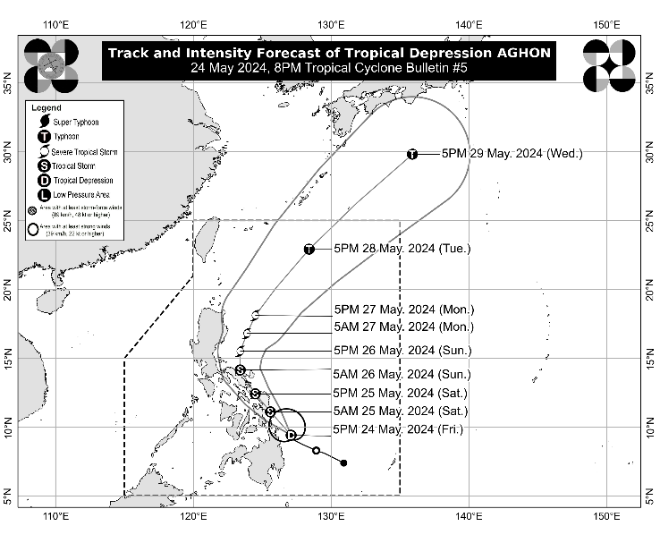
The center of Tropical Depression AGHON was estimated based on all available data at 145 km East of Surigao City, Surigao del Norte (9.7°N, 126.8°E)
Intensity
Maximum sustained winds of 55 km/h near the center, gustiness of up to 70 km/h, and central pressure of 1006 hPa
Present Movement
Northwestward at 20 km/h
Extent of Tropical Cyclone Winds
Strong winds extend outwards up to 220 km from the center
TRACK AND INTENSITY FORECAST
Date and Time | Center Position |  |  |  | Intensity |  | Movement dir. and speed (km/h)
 | Lat.  (°N) | Lon.  (°E) | Location |  | MSW  (km/h) | Cat.
12-Hour Forecast  5:00 AM  25 May 2024 | 11.1 | 125.6 | In the coastal waters of Salcedo, Eastern Samar |  | 65 | TS | NW 20
24-Hour Forecast  5:00 PM  25 May 2024 | 12.4 | 124.5 | In the vicinity of Borbon, Northern Samar |  | 75 | TS | NW 15
36-Hour Forecast  5:00 AM  26 May 2024 | 14.1 | 123.4 | In the coastal waters of Siruma, Camarines Sur |  | 85 | TS | NNW 20
48-Hour Forecast  5:00 PM  26 May 2024 | 15.5 | 123.4 | 190 km East of Baler, Aurora |  | 95 | STS | N 15
60-Hour Forecast  5:00 AM  27 May 2024 | 16.8 | 123.9 | 200 km East Northeast of Casiguran, Aurora |  | 100 | STS | NNE 15
72-Hour Forecast  5:00 PM  27 May 2024 | 18.1 | 124.5 | 305 km East of Aparri, Cagayan |  | 110 | STS | NNE 15
96-Hour Forecast  5:00 PM  28 May 2024 | 22.9 | 128.4 | 720 km East Northeast of Itbayat, Batanes |  | 120 | TY | NE 30
120-Hour Forecast  5:00 PM  29 May 2024 | 29.8 | 135.9 | 1,730 km Northeast of Extreme Northern Luzon (OUTSIDE PAR) |  | 120 | TY | NE 45

TROPICAL CYCLONE WIND SIGNALS (TCWS) IN EFFECT
TCWS No. | Luzon | Visayas | Mindanao
1  Wind threat: Strong winds | Quezon (Calauag, Guinayangan, Lopez, Buenavista, Catanauan, Mulanay, San Narciso, San Francisco, San Andres, Tagkawayan), Sorsogon, Albay, Catanduanes, Camarines Sur, Camarines Norte, Masbate including Ticao Island, and Burias Island | Eastern Samar, Samar, Northern Samar, Leyte, Southern Leyte, Biliran, Cebu (San Remigio, Tabogon, City of Bogo, Medellin, Daanbantayan, Borbon) including Camotes Islands, Bantayan Islands, and Bohol (Pres. Carlos P. Garcia, Bien Unido, Trinidad, Anda, Candijay, Ubay, Mabini, Alicia, San Miguel, Talibon) | Dinagat Islands, Surigao del Norte including Siargao and Bucas Grande Islands, Surigao del Sur, Agusan del Sur (Sibagat, City of Bayugan, Prosperidad, San Francisco, Rosario, Bunawan, Trento), and Agusan del Norte
Warning lead time: 36 hours
Range of wind speeds: 39 to 61 km/h (Beaufort 6 to 7)
Potential impacts of winds: Minimal to minor threat to life and property

HAZARDS AFFECTING LAND AREAS
Heavy Rainfall Outlook

Forecast accumulated rainfall: From tonight until tomorrow evening
- 100-200 mm: Albay, Sorsogon, Eastern Visayas, Surigao del Norte, and Dinagat Islands
- 50-100 mm: Southern portion of Quezon, Masbate including Ticao and Burias Islands, Catanduanes, the eastern portion of Camarines Sur, Western Visayas, Surigao del Sur,and Zamboanga del Norte

Forecast accumulated rainfall: From tomorrow evening to Sunday evening
- 100-200 mm: Bicol Region and Northern Samar
- 50-100 mm: The rest of Eastern Visayas, and the southern portion of Quezon and Polillo Islands

Forecast accumulated rainfall: From Sunday evening to Monday evening
- 50-100 mm: Catanduanes, Camarines Norte, Camarines Sur and the southern portion of Quezon and Polillo Islands

Forecast rainfall are generally higher in elevated or mountainous areas. Under these conditions, flooding and rain-induced landslides are possible especially in areas that are highly or very highly susceptible to these hazards as identified in hazard maps and in localities that experienced considerable amounts of rainfall for the past several days.

Severe Winds

The wind signals warn the public of the general wind threat over an area due to the tropical cyclone. Local winds may be slightly stronger/enhanced in coastal and upland/mountainous areas exposed to winds. Winds are less strong in areas sheltered from the prevailing wind direction.

- Minimal to minor impacts from strong winds are possible within any of the areas under Wind Signal No. 1.

Areas in Central Visayas and Quezon may be placed under Wind Signal No.1 in the next bulletin. The highest possible Wind Signal that may be hoisted during the passage of AGHON is Wind Signal No. 2.

HAZARDS AFFECTING COASTAL WATERS
Tonight, AGHON will bring moderate to rough seas (1.5 to 3.5 m) over the coastal waters along the northern and eastern seaboards of Eastern Visayas and the eastern seaboard of Caraga Region. Mariners of motor bancas and similarly-sized vessels are advised to take precautionary measures while venturing out to sea and, if possible, avoid navigating in these conditions, especially if inexperienced or operating ill-equipped vessels.

TRACK AND INTENSITY OUTLOOK
AGHON is forecast to move generally west northwestward to northwestward from tonight until tomorrow while slowly intensifying. On the track forecast, AGHON is forecast to make landfall over the southern portion of Eastern Samar or Dinagat Islands by tomorrow morning as a tropical storm. Afterwards, AGHON will pass north northwestward through the coast of Northern Samar, then may possibly make another landfall over the southeastern portion of Bicol Region (Sorsogon, Albay, or Catanduanes) by tomorrow evening as a tropical storm. On Sunday, AGHON will begin recurving generally northward or north northeastward over the waters east of Luzon while starting to continuously intensify. Current forecast scenario shows intensification into a severe tropical storm by Sunday and into a typhoon by Tuesday.

Considering these developments, the public and disaster risk reduction and management offices concerned are advised to take all necessary measures to protect life and property. Persons living in areas identified to be highly or very highly susceptible to these hazards are advised to follow evacuation and other instructions from local officials. For heavy rainfall warnings, thunderstorm/rainfall advisories, and other severe weather information specific to your area, please monitor products issued by your local PAGASA Regional Services Division.

The next tropical cyclone bulletin will be issued at 11:00 PM today.

DOST-PAGASA

