“AGHON” CONTINUES TO MOVE NORTHWESTWARD TOWARDS THE LEYTE GULF.
Location of Center (10:00 PM) |  |  |  | 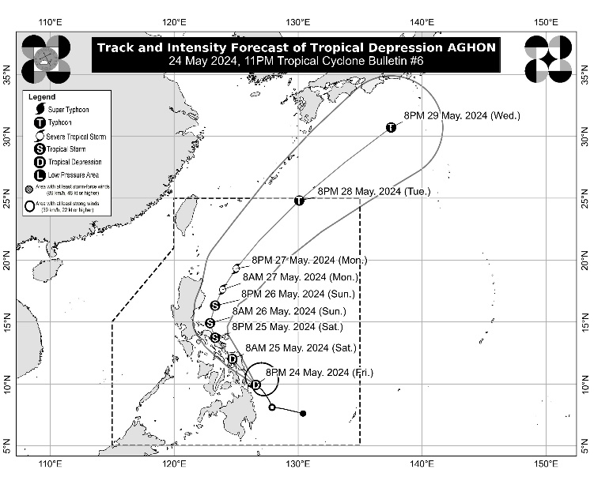
The center of Tropical Depression AGHON was estimated based on all available data over the coastal waters of San Isidro, Surigao del Norte (9.7°N, 126.8°E)
Intensity
Maximum sustained winds of 55 km/h near the center, gustiness of up to 70 km/h, and central pressure of 1006 hPa
Present Movement
Northwestward at 20 km/h
Extent of Tropical Cyclone Winds
Strong winds extend outwards up to 220 km from the center
TRACK AND INTENSITY FORECAST
Date and Time | Center Position |  |  |  | Intensity |  | Movement dir. and speed (km/h)
 | Lat.  (°N) | Lon.  (°E) | Location |  | MSW  (km/h) | Cat.
12-Hour Forecast  8:00 AM  25 May 2024 | 12.0 | 124.7 | In the vicinity of Santa Margarita, Samar |  | 55 | TD | NW 25
24-Hour Forecast  8:00 PM  25 May 2024 | 13.7 | 123.3 | In the vicinity of Calabanga, Camarines Sur |  | 65 | TS | NW 20
36-Hour Forecast  8:00 AM  26 May 2024 | 14.9 | 122.9 | 85 km North of Daet, Camarines Norte or 135 km East of Infanta, Quezon |  | 65 | TS | NNW 10
48-Hour Forecast  8:00 PM  26 May 2024 | 16.3 | 123.3 | 125 km East of Casiguran, Aurora |  | 75 | TS | NNE 15
60-Hour Forecast  8:00 AM  27 May 2024 | 17.6 | 123.9 | 225 km East of Tuguegarao City, Cagayan |  | 95 | STS | NNE 15
72-Hour Forecast  8:00 PM  27 May 2024 | 19.3 | 125.0 | 370 km East of Calayan, Cagayan |  | 110 | STS | NNE 20
96-Hour Forecast  8:00 PM  28 May 2024 | 24.8 | 130.1 | 960 km East Northeast of Extreme Northern Luzon |  | 120 | TY | NE 35
120-Hour Forecast  8:00 PM  29 May 2024 | 30.7 | 137.5 | 1,915 km Northeast of Extreme Northern Luzon (OUTSIDE PAR) |  | 120 | TY | NE 40

TROPICAL CYCLONE WIND SIGNALS (TCWS) IN EFFECT
TCWS No. | Luzon | Visayas | Mindanao
1  Wind threat: Strong winds | The southeastern portion of Quezon (Calauag, Guinayangan, Lopez, Buenavista, Catanauan, Mulanay, San Narciso, San Francisco, San Andres, Tagkawayan), Camarines Norte, Camarines Sur, Catanduanes, Albay, Sorsogon, and Masbate including Burias and Ticao Islands | Northern Samar, Samar, Eastern Samar, Biliran, Leyte, Southern Leyte Southern Leyte, Biliran, the extreme northern portion of Cebu (San Remigio, Tabogon, City of Bogo, Medellin, Daanbantayan, Borbon) including Camotes and Bantayan Islands, and the northeastern portion of Bohol (Pres. Carlos P. Garcia, Bien Unido, Trinidad, Anda, Candijay, Ubay, Mabini, Alicia, San Miguel, Talibon) | Dinagat Islands, Surigao del Norte including Siargao and Bucas Grande Islands, Surigao del Sur, Agusan del Norte, and the eastern portion of Agusan del Sur (Sibagat, City of Bayugan, Prosperidad, San Francisco, Rosario, Bunawan, Trento).
Warning lead time: 36 hours
Range of wind speeds: 39 to 61 km/h (Beaufort 6 to 7)
Potential impacts of winds: Minimal to minor threat to life and property

HAZARDS AFFECTING LAND AREAS
Heavy Rainfall Outlook

Forecast accumulated rainfall: From tonight until tomorrow evening
- 100-200 mm: Albay, Sorsogon, Eastern Visayas, Surigao del Norte, and Dinagat Islands
- 50-100 mm: The southeastern portion of Quezon, the rest of Bicol Region, and the northern portions of Western Visayas and Cebu.

Forecast accumulated rainfall: From tomorrow evening to Sunday evening
- 100-200 mm: Bicol Region
- 50-100 mm: Polillo Islands, the southern portion of Quezon, and Northern Samar

Forecast rainfall are generally higher in elevated or mountainous areas. Under these conditions, flooding and rain-induced landslides are possible especially in areas that are highly or very highly susceptible to these hazards as identified in hazard maps and in localities that experienced considerable amounts of rainfall for the past several days.
Severe Winds

The wind signals warn the public of the general wind threat over an area due to the tropical cyclone. Local winds may be slightly stronger/enhanced in coastal and upland/mountainous areas exposed to winds. Winds are less strong in areas sheltered from the prevailing wind direction.

- Minimal to minor impacts from strong winds are possible within any of the areas under Wind Signal No. 1.

Other areas in CALABARZON may be placed under Wind Signal No.1 in the next bulletin. The highest possible Wind Signal that may be hoisted during the passage of AGHON is Wind Signal No. 2.

HAZARDS AFFECTING COASTAL WATERS
Tonight to tomorrow evening: AGHON will bring moderate to rough seas (1.5 to 3.5 m) over the coastal waters along the seaboards of Bicol Region, the southern seaboard of Quezon, the eastern seaboard of Eastern Visayas, the western seaboard of Samar and Northern Samar, and the eastern seaboard of Caraga Region. Mariners of motor bancas and similarly-sized vessels are advised to take precautionary measures while venturing out to sea and, if possible, avoid navigating in these conditions, especially if inexperienced or operating ill-equipped vessels.

TRACK AND INTENSITY OUTLOOK
- AGHON is forecast to continue moving generally northwestward and is forecast to make landfall as a tropical depression in the vicinity of Eastern Samar in the next 12 hours (likely by tomorrow early morning). However, there is an increasing possibility of landfall in the vicinity of Leyte and/or Dinagat Islands within the next 12 hours due to the westward shift in track forecast.
- Afterwards, AGHON will continue generally northwestward, emerge over the Samar Sea, and cross the Bicol Peninsula between tomorrow afternoon and Sunday early morning. It is forecast to emerge over the waters north of Camarines Provinces by Sunday morning. From the time it emerges over Samar Sea up to its passage over Bicol Region, AGHON is forecast to reach tropical storm category.
- On Sunday, AGHON will begin its recurvature towards the northeast. As it moves over the Philippine Sea, the tropical cyclone is forecast to continuously intensify and may reach typhoon category on Tuesday. On the track forecast, AGHON may exit the PAR region no earlier than Tuesday.

Considering these developments, the public and disaster risk reduction and management offices concerned are advised to take all necessary measures to protect life and property. Persons living in areas identified to be highly or very highly susceptible to these hazards are advised to follow evacuation and other instructions from local officials. For heavy rainfall warnings, thunderstorm/rainfall advisories, and other severe weather information specific to your area, please monitor products issued by your local PAGASA Regional Services Division.

The next tropical cyclone bulletin will be issued at 2:00 AM tomorrow.

DOST-PAGASA

