“AGHON” CONTINUES TO MOVE NORTHWESTWARD AND IS NOW OVER THE SAMAR SEA.
Location of Center (7:00 AM) |  |  |  | 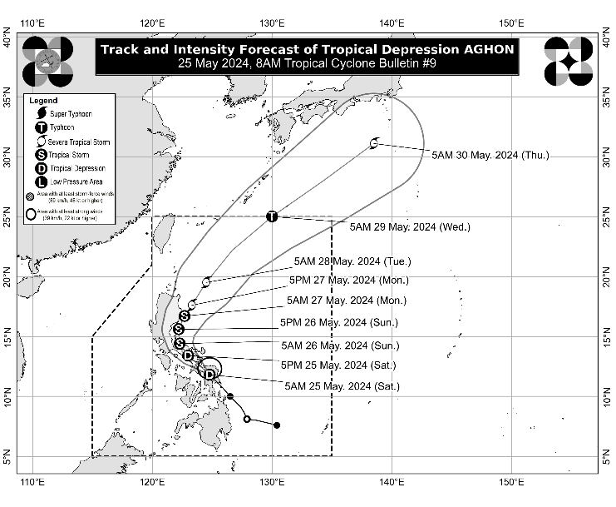
The center of Tropical Depression AGHON was estimated based on all available data over the coastal waters of Calbayog City, Samar (12.0°N, 124.6°E)
Intensity
Maximum sustained winds of 55 km/h near the center, gustiness of up to 85 km/h, and central pressure of 1004 hPa
Present Movement
Northwestward at 30 km/h
Extent of Tropical Cyclone Winds
Strong winds extend outwards up to 140 km from the center
TRACK AND INTENSITY FORECAST
Date and Time | Center Position |  |  |  | Intensity |  | Movement dir. and speed (km/h)
 | Lat.  (°N) | Lon.  (°E) | Location |  | MSW  (km/h) | Cat.
12-Hour Forecast  5:00 PM  25 May 2024 | 13.4 | 123.0 | Over the coastal waters of Pasacao, Camarines Sur |  | 55 | TD | NW 20
24-Hour Forecast  5:00 AM  26 May 2024 | 14.4 | 122.3 | Over the coastal waters of Capalonga, Camarines Norte |  | 65 | TS | NW 10
36-Hour Forecast  5:00 PM  26 May 2024 | 15.6 | 122.2 | 65 km East Southeast of Baler, Aurora |  | 75 | TS | N 10
48-Hour Forecast  5:00 AM  27 May 2024 | 16.7 | 122.7 | Over the coastal waters of Dinapigue, Aurora |  | 85 | TS | NNE 10
60-Hour Forecast  5:00 PM  27 May 2024 | 17.6 | 123.3 | 165 km East of Tuguegarao City, Cagayan |  | 100 | STS | NNE 10
72-Hour Forecast  5:00 AM  28 May 2024 | 19.5 | 124.5 | 320 km East of Calayan, Cagayan |  | 110 | STS | NNE 20
96-Hour Forecast  5:00 AM  29 May 2024 | 25.0 | 130.0 | 960 km East Northeast of Extreme Northern Luzon |  | 120 | TY | NE 35
120-Hour Forecast  5:00 AM  30 May 2024 | 31.1 | 138.5 | 2,020 km Northeast of Extreme Northern Luzon (OUTSIDE PAR) |  | 120 | TY | NE 45

TROPICAL CYCLONE WIND SIGNALS (TCWS) IN EFFECT
TCWS No. | Luzon | Visayas | Mindanao
1  Wind threat: Strong winds | Aurora, Polillo Islands, the northern and southeastern portion of Quezon (Calauag, Guinayangan, Lopez, Buenavista, Catanauan, Mulanay, San Narciso, San Francisco, San Andres, Tagkawayan, Gumaca, Quezon, Alabat, Perez, Plaridel, Pitogo, Macalelon, General Luna, Atimonan, Unisan, Mauban, Real, Infanta, General Nakar, Padre Burgos, Agdangan), the eastern portion of Romblon (Cajidiocan, Magdiwang, San Fernando, Romblon), the eastern portion of Marinduque (Santa Cruz, Torrijos), Camarines Norte, Camarines Sur, Catanduanes, Albay, Sorsogon, and Masbate including Burias and Ticao Islands | Northern Samar, Samar, Eastern Samar, Biliran, the northern portion of Leyte (Tunga, Pastrana, San Miguel, Matag-Ob, Tolosa, Palo, Calubian, Leyte, Mayorga, Julita, Carigara, Babatngon, Dagami, Jaro, San Isidro, Santa Fe, Albuera, Villaba, La Paz, Palompon, Tabontabon, Tanauan, Merida, Ormoc City, Isabel, Dulag, Capoocan, Alangalang, Burauen, Tabango, Tacloban City, Kananga, Barugo), and the extreme northern portion of Cebu (San Remigio, Tabogon, City of Bogo, Medellin, Daanbantayan, Borbon) including Camotes and Bantayan Islands | -
Warning lead time: 36 hours
Range of wind speeds: 39 to 61 km/h (Beaufort 6 to 7)
Potential impacts of winds: Minimal to minor threat to life and property

HAZARDS AFFECTING LAND AREAS
Heavy Rainfall Outlook

Forecast accumulated rainfall: Today
- 100-200 mm: Bicol Region, Northern Samar, and the northern portion of Samar
- 50-100 mm: The southern portion of Quezon, Polillo Islands, Marinduque, the eastern portion of Romblon, the rest of Samar, Eastern Samar, Biliran, and the northern portions of Western Visayas, Leyte, and Cebu

Forecast accumulated rainfall: Tomorrow
- 100-200 mm: Camarines Norte, Camarines Sur, and Catanduanes.
- 50-100 mm: Quezon, Aurora, and the rest of Bicol Region.

Forecast rainfall are generally higher in elevated or mountainous areas. Under these conditions, flooding and rain-induced landslides are possible especially in areas that are highly or very highly susceptible to these hazards as identified in hazard maps and in localities that experienced considerable amounts of rainfall for the past several days.
Severe Winds

The wind signals warn the public of the general wind threat over an area due to the tropical cyclone. Local winds may be slightly stronger/enhanced in coastal and upland/mountainous areas exposed to winds. Winds are less strong in areas sheltered from the prevailing wind direction.

- Minimal to minor impacts from strong winds are possible within any of the areas under Wind Signal No. 1.

The highest possible Wind Signal that may be hoisted during the passage of AGHON is Wind Signal No. 2.

HAZARDS AFFECTING COASTAL WATERS
Today: AGHON will bring moderate to rough seas (1.5 to 3.5 m) over the coastal waters along the seaboards of Bicol Region, the southern seaboard of Quezon, the eastern seaboard of Eastern Visayas, the western seaboard of Samar and Northern Samar, and the eastern seaboard of Caraga Region. Mariners of motor bancas and similarly-sized vessels are advised to take precautionary measures while venturing out to sea and, if possible, avoid navigating in these conditions, especially if inexperienced or operating ill-equipped vessels.

TRACK AND INTENSITY OUTLOOK
- AGHON is forecast to move generally northwestward over the Samar Sea and cross the Bicol Peninsula between this afternoon and tomorrow early morning. It is forecast to emerge either over Lamon Bay or the waters north of Camarines Provinces by tomorrow early morning. This may be followed by another landfall in the vicinity of Polillo Islands tomorrow morning. During this period, AGHON may reach tropical storm category.
- Around tomorrow afternoon, AGHON will begin its recurvature towards the northeast. As it moves over the Philippine Sea, the tropical cyclone is forecast to continuously intensify and may reach typhoon category on Tuesday. On the track forecast, AGHON may exit the PAR region no earlier than Tuesday.

Considering these developments, the public and disaster risk reduction and management offices concerned are advised to take all necessary measures to protect life and property. Persons living in areas identified to be highly or very highly susceptible to these hazards are advised to follow evacuation and other instructions from local officials. For heavy rainfall warnings, thunderstorm/rainfall advisories, and other severe weather information specific to your area, please monitor products issued by your local PAGASA Regional Services Division.

The next tropical cyclone bulletin will be issued at 11:00 AM today.

DOST-PAGASA

