“JULIAN” MAINTAINS ITS STRENGTH WHILE MOVING NORTHWESTWARD OVER THE PHILIPPINE SEA EAST OF CAGAYAN.
Location of Center (4:00 PM) |  |  |  | 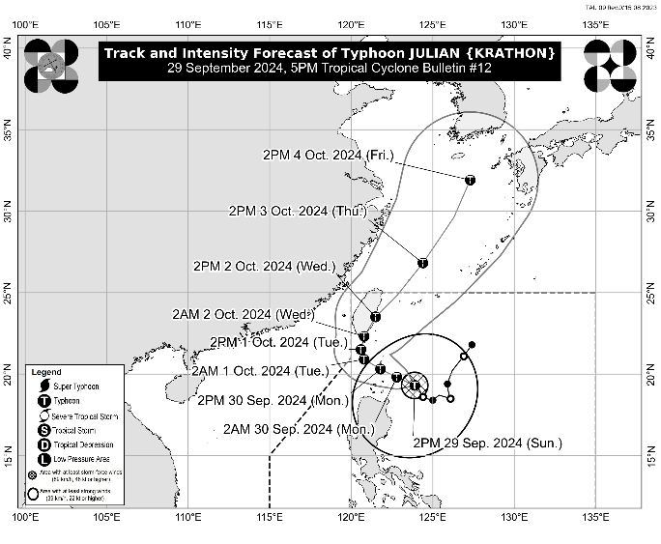
The center of the eye of Typhoon JULIAN was estimated based on all available data at 235 km East of Calayan, Cagayan (19.5°N, 123.7°E)
Intensity
Maximum sustained winds of 120 km/h near the center, gustiness of up to 150 km/h, and central pressure of 975 hPa
Present Movement
Northwestward at 15 km/h
Extent of Tropical Cyclone Winds
Strong to typhoon-force winds extend outwards up to 490 km from the center
TRACK AND INTENSITY FORECAST
Date and Time | Center Position |  |  |  | Intensity |  | Movement dir. and speed (km/h)
 | Lat.  (°N) | Lon.  (°E) | Location |  | MSW  (km/h) | Cat.
12-Hour Forecast  2:00 AM  30 September 2024 | 19.8 | 122.8 | 110 km Southeast of Basco, Batanes |  | 140 | TY | WNW 10
24-Hour Forecast  2:00 PM  30 September 2024 | 20.3 | 121.8 | Over the coastal waters of Sabtang Is., Batanes |  | 155 | TY | WNW 10
36-Hour Forecast  2:00 AM  01 October 2024 | 20.9 | 120.8 | 110 km West of Itbayat, Batanes |  | 165 | TY | WNW 10
48-Hour Forecast  2:00 PM  01 October 2024 | 21.5 | 120.6 | 150 km West Northwest of Itbayat, Batanes |  | 175 | TY | NNW Slowly
60-Hour Forecast  2:00 AM  02 October 2024 | 22.3 | 120.8 | 200 km North Northwest of Itbayat, Batanes |  | 175 | TY | NNE 10
72-Hour Forecast  2:00 PM  02 October 2024 | 23.5 | 121.5 | 305 km North of Itbayat, Batanes |  | 175 | TY | NNE 15
96-Hour Forecast  2:00 PM  03 October 2024 | 26.8 | 124.4 | 720 km North Northeast of Itbayat, Batanes (OUTSIDE PAR) |  | 155 | TY | NE 20
120-Hour Forecast  2:00 PM  04 October 2024 | 31.9 | 127.3 | 1,350 km North Northeast of Extreme Northern Luzon (OUTSIDE PAR) |  | 150 | TY | NNE 25

TROPICAL CYCLONE WIND SIGNALS (TCWS) IN EFFECT
TCWS No. | Luzon | Visayas | Mindanao
3  Wind threat:  Storm-Force winds | Batanes and the northeastern portion of Babuyan Islands (Babuyan Is.) | - | -
Warning lead time: 18 hours
Range of wind speeds: 89 to 117 km/h (Beaufort 9 to 11)
Potential impacts of winds: Moderate to significant threat to life and property
2  Wind threat:  Gale-Force winds | Mainland Cagayan, the rest of Babuyan Islands (Camiguin Is., Calayan Is., Dalupiri Is., Fuga Is.), Apayao, and the northern and central portions of Ilocos Norte (Pagudpud, Adams, Dumalneg, Bangui, Burgos, Pasuquin, Vintar, Carasi, Nueva Era, Solsona, Piddig, Dingras, Sarrat, San Nicolas, Laoag City, Bacarra) | - | -
Warning lead time: 24 hours
Range of wind speeds: 62 to 88 km/h (Beaufort 8 to 9)
Potential impacts of winds: Minor to moderate threat to life and property
1  Wind threat:  Strong winds | The rest of Ilocos Norte, Ilocos Sur, La Union, Abra, Kalinga, Ifugao, Mountain Province, Benguet, Isabela, Nueva Vizcaya, Quirino, and the northern and central portions of Aurora (Dilasag, Casiguran, Dinalungan, Dipaculao) | - | -
Warning lead time: 36 hours
Range of wind speeds: 39 to 61 km/h (Beaufort 6 to 7)
Potential impacts of winds: Minimal to minor threat to life and property

OTHER HAZARDS AFFECTING LAND AREAS
Heavy Rainfall Outlook

Refer to Weather Advisory No. 12 issued at 5:00 PM today for the heavy rainfall outlook due to Typhoon JULIAN.

Severe Winds

The wind signals warn the public of the general wind threat over an area due to the tropical cyclone. Local winds may be slightly stronger/enhanced in coastal and upland/mountainous areas exposed to winds. Winds are less strong in areas sheltered from the prevailing wind direction.

- Moderate to significant impacts from storm-force winds are possible within any of the localities where Wind Signal No. 3 is hoisted.
- Minor to moderate impacts from strong winds are possible within any of the localities where Wind Signal No. 2 is hoisted.
- Minimal to minor impacts from strong winds are possible within any of the areas under Wind Signal No. 1.

The highest Wind Signal that may be hoisted during the occurrence of JULIAN is Wind Signal No. 4.

Furthermore, the wind flow coming towards the circulation of Typhoon JULIAN may also bring strong to gale-force gusts over the following areas (especially in coastal and upland areas exposed to winds):

- Today (29 September): Aurora, CALABARZON, Romblon, and Bicol Region
- Tomorrow (30 September): Pangasinan, Zambales, Bataan, Aurora, Quezon, Romblon, and Bicol Region.

Coastal Inundation

There is a moderate to significant of storm surge may occur in the next 48 hours in the low-lying or exposed coastal localities of Batanes, Cagayan, and Ilocos Norte. For more information, refer to Storm Surge Warning No. 1 issued at 2:00 PM today.

HAZARDS AFFECTING COASTAL WATERS
24-Hour Sea Condition Outlook

A Gale Warning is hoisted over the northern and eastern seaboards of Northern Luzon. Sea travel is risky for small seacrafts, including all types of motorbancas. For more information, refer to Gale Warning No. 4 issued at 5:00 PM today.

Very rough sea condition over the following coastal waters:
- Up to 9.0 m over the seaboards of Batanes
- Up to 8.0 m over the seaboards of Babuyan Islands
- Sea travel is risky for most types or tonnage of vessels. Mariners of these vessels are advised to remain in port or seek safe shelter or harbor.

Rough sea condition over the following coastal waters
- Up to 4.5 m over the northern seaboard of mainland Cagayan and the northern seaboard of Ilocos Norte
- Up to 3.5 m over and the remaining seaboard of Cagayan and the seaboard of Isabela
- Up to 3.0 m over the seaboard of the northern portion of Aurora
- Mariners of small seacrafts, including all types of motorbancas, are advised not to venture out to sea under these conditions, especially if inexperienced or operating ill-equipped vessels

Moderate sea condition over the following coastal waters:
- Up to 2.5 m over the remaining seaboard of Ilocos Norte
- Mariners of motorbancas and similarly-sized vessels are advised to take precautionary measures while venturing out to sea and, if possible, avoid navigation under these conditions.

TRACK AND INTENSITY OUTLOOK
- JULIAN is forecast to move generally west northwestward to north northwestward from today through Tuesday (1 October) morning towards the Batanes-Babuyan Islands area, before accelerating north northeastward over the waters east of Taiwan on Tuesday afternoon onwards. On the track forecast, a landfall or close approach scenario by tomorrow (30 September) over Batanes and/or Babuyan Islands is highly likely.
- JULIAN is forecast to continue intensifying over the next 24-36 hours as it moves towards Batanes and/or Babuyan Islands. With the current trend in its intensification, the possibility of reaching super typhoon category is not ruled out.

Considering these developments, the public and disaster risk reduction and management offices concerned are advised to take all necessary measures to protect life and property. Persons living in areas identified to be highly or very highly susceptible to these hazards are advised to follow evacuation and other instructions from local officials. For heavy rainfall warnings, thunderstorm/rainfall advisories, and other severe weather information specific to your area, please monitor products issued by your local PAGASA Regional Services Division.

The next tropical cyclone bulletin will be issued at 8:00 PM today.

DOST-PAGASA

