“JULIAN” FURTHER INTENSIFIES AS IT CONTINUES TO THREATEN BATANES AND BABUYAN ISLANDS.
Location of Center (10:00 PM) |  |  |  | 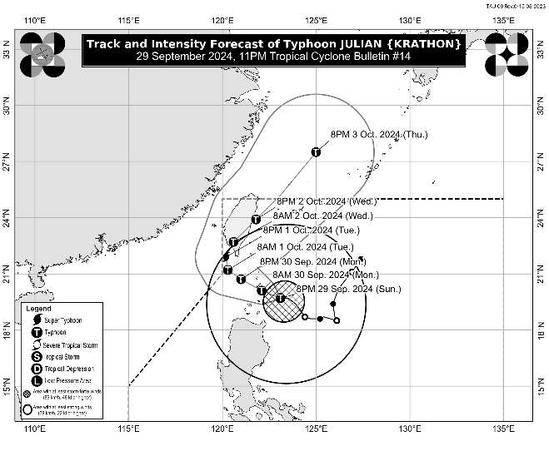
The center of the eye of Typhoon JULIAN was estimated based on all available data at 125 km Southeast of Basco, Batanes (19.7°N, 122.9°E)
Intensity
Maximum sustained winds of 150 km/h near the center, gustiness of up to 185 km/h, and central pressure of 960 hPa
Present Movement
Westward at 15 km/h
Extent of Tropical Cyclone Winds
Strong to typhoon-force winds extend outwards up to 520 km from the center
TRACK AND INTENSITY FORECAST
Date and Time | Center Position |  |  |  | Intensity |  | Movement dir. and speed (km/h)
 | Lat.  (°N) | Lon.  (°E) | Location |  | MSW  (km/h) | Cat.
12-Hour Forecast  8:00 AM  30 September 2024 | 20.1 | 122.1 | Over the coastal waters of Sabtang, Batanes |  | 155 | TY | WNW 10
24-Hour Forecast  8:00 PM  30 September 2024 | 20.7 | 121.0 | 90 km West of Itbayat, Batanes |  | 165 | TY | WNW 10
36-Hour Forecast  8:00 AM  01 October 2024 | 21.2 | 120.3 | 165 km West Northwest of Itbayat, Batanes |  | 175 | TY | NW 10
48-Hour Forecast  8:00 PM  01 October 2024 | 21.9 | 120.2 | 210 km Northwest of Itbayat, Batanes |  | 185 | STY | N Slowly
60-Hour Forecast  8:00 AM  02 October 2024 | 22.7 | 120.6 | 250 km North Northwest of Itbayat, Batanes or in the vicinity of Pingtung County, Taiwan |  | 140 | TY | NNE 10
72-Hour Forecast  8:00 PM  02 October 2024 | 23.9 | 121.8 | 345 km North of Itbayat, Batanes |  | 130 | TY | NE 15
96-Hour Forecast  8:00 PM  03 October 2024 | 27.5 | 125.0 | 815 km North Northeast of Extreme Northern Luzon (OUTSIDE PAR) |  | 130 | TY | NE 20

TROPICAL CYCLONE WIND SIGNALS (TCWS) IN EFFECT
TCWS No. | Luzon | Visayas | Mindanao
4  Wind threat:  Typhoon-force winds | Batanes and the northeastern portion of Babuyan Islands (Babuyan Is.) | - | -
Warning lead time: 12 hours
Range of wind speeds: 118 to 184 km/h (Beaufort 12)
Potential impacts of winds: Significant to severe threat to life and property
3  Wind threat:  Storm-force winds | The rest of Babuyan Islands | - | -
Warning lead time: 18 hours
Range of wind speeds: 89 to 117 km/h (Beaufort 10 to 11)
Potential impacts of winds: Moderate to significant threat to life and property
2  Wind threat:  Gale-force winds | Mainland Cagayan, Apayao, and Ilocos Norte | - | -
Warning lead time: 24 hours
Range of wind speeds: 62 to 88 km/h (Beaufort 8 to 9)
Potential impacts of winds: Minor to moderate threat to life and property
1  Wind threat:  Strong winds | Ilocos Sur, La Union, Abra, Kalinga, Ifugao, Mountain Province, Benguet, Isabela, Nueva Vizcaya, Quirino, and the northern and central portions of Aurora (Dilasag, Casiguran, Dinalungan, Dipaculao, Maria Aurora, Baler, San Luis) | - | -
Warning lead time: 36 hours
Range of wind speeds: 39 to 61 km/h (Beaufort 6 to 7)
Potential impacts of winds: Minimal to minor threat to life and property

OTHER HAZARDS AFFECTING LAND AREAS
Heavy Rainfall Outlook

Refer to Weather Advisory No. 14 issued at 11:00 PM today for the heavy rainfall outlook due to Typhoon JULIAN.

Severe Winds

The wind signals warn the public of the general wind threat over an area due to the tropical cyclone. Local winds may be slightly stronger/enhanced in coastal and upland/mountainous areas exposed to winds. Winds are less strong in areas sheltered from the prevailing wind direction.

- Significant to severe impacts from typhoon-force winds are possible within any of the localities where Wind Signal No. 4 is hoisted.
- Moderate to significant impacts from storm-force winds are possible within any of the localities where Wind Signal No. 3 is hoisted.
- Minor to moderate impacts from gale-force winds are possible within any of the localities where Wind Signal No. 2 is hoisted.
- Minimal to minor impacts from strong winds are possible within any of the areas under Wind Signal No. 1.

Furthermore, the wind flow coming towards the circulation of Typhoon JULIAN may also bring strong to gale-force gusts over the following areas (especially in coastal and upland areas exposed to winds):

- Tonight through tomorrow (30 September): Pangasinan, Zambales, Bataan, Metro Manila, CALABARZON, Romblon, and Bicol Region
- Tuesday (1 October): Ilocos Region, Cordillera Administrative Region, northern and eastern portions of mainland Cagayan, the eastern portion of Isabela, Aurora, Zambales, Bataan, Metro Manila, CALABARZON, Romblon, Camarines Norte, Camarines Sur, and Catanduanes

Coastal Inundation

There is a moderate to high risk of life threatening storm surge in the next 48 hours over the low-lying or exposed coastal localities of Batanes, Babuyan Islands, and northern mainland Cagayan. For more information, refer to Storm Surge Warning No. 2 issued at 8:00 PM today.

HAZARDS AFFECTING COASTAL WATERS
A Gale Warning is hoisted over the northern and eastern seaboards of Northern Luzon. For more information, refer to Gale Warning No. 5A issued at 11:00 PM today.

24-Hour Sea Condition Outlook

High to very high seas over the following coastal waters:
- Up to 14.0 m over the seaboards of Batanes
- Up to 8.0 m over the seaboards of Babuyan Islands
- Sea travel is risky all types or tonnage of vessels. Mariners are advised to remain in port or seek safe shelter or harbor.

Very rough sea condition over the following coastal waters
- Up to 5.5 m over the northern seaboard of Ilocos Norte
- Up to 5.0 m over the northern seaboard of mainland Cagayan and the remaining seaboard of Ilocos Norte
- Sea travel is risky for most types or tonnage of vessels, including all small seacrafts and motorbancas. Mariners of these vessels are advised to remain in port or seek safe shelter or harbor.

Moderate to rough sea condition over the following coastal waters
- Up to 4.0 m over the remaining seaboard of Cagayan and seaboard of Ilocos Sur
- Up to 3.5 m over seaboard of Isabela
- Up to 3.0 m over the seaboard of the northern portion of Aurora and the remaining seaboard of Ilocos Region
- Up to 2.5 m over the remaining seaboard of Aurora and the northern and eastern seaboard of Polillo Islands
- Mariners of small seacrafts, including all types of motorbancas, are advised not to venture out to sea under these conditions, especially if inexperienced or operating ill-equipped vessels

TRACK AND INTENSITY OUTLOOK
- JULIAN is forecast to move generally west northwestward through Tuesday morning (01 October) over the Balintang and Bashi Channels. On the track forecast, the typhoon will make landfall or pass very close to Batanes tomorrow (30 September) morning or afternoon. On Tuesday afternoon, JULIAN will be sharply turning northward toward Taiwan, where it is forecast to make another landfall on Tuesday evening or Wednesday (2 October) morning. It will then turn north northeastward and emerge over the waters east of Taiwan on Wednesday afternoon or evening. Afterwards, the typhoon will accelerate north northeastward over the East China Sea and exit the Philippine Area of Responsibility on Thursday (3 October).
- JULIAN is forecast to continue intensifying over the next 48 hours and may reach super typhoon category before making its landfall over southern Taiwan. In this case, JULIAN will pass near or over Batanes during its intensification period.

Considering these developments, the public and disaster risk reduction and management offices concerned are advised to take all necessary measures to protect life and property. Persons living in areas identified to be highly or very highly susceptible to these hazards are advised to follow evacuation and other instructions from local officials. For heavy rainfall warnings, thunderstorm/rainfall advisories, and other severe weather information specific to your area, please monitor products issued by your local PAGASA Regional Services Division.

The next tropical cyclone bulletin will be issued at 2:00 AM tomorrow.

DOST-PAGASA

