“JULIAN” FURTHER INTENSIFIES AND IS NEARING SUPER TYPHOON CATEGORY.
Location of Center (7:00 AM) |  |  |  | 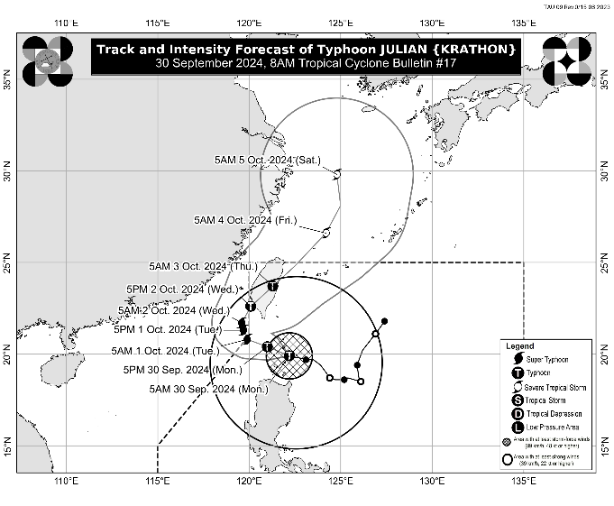
The center of the eye of Typhoon JULIAN was estimated based on all available data over the coastal waters of Balintang Is., Calayan, Cagayan (19.9°N, 122.2°E)
Intensity
Maximum sustained winds of 175 km/h near the center, gustiness of up to 215 km/h, and central pressure of 940 hPa
Present Movement
West Northwestward at 10 km/h
Extent of Tropical Cyclone Winds
Strong to typhoon-force winds extend outwards up to 560 km from the center
TRACK AND INTENSITY FORECAST
Date and Time | Center Position |  |  |  | Intensity |  | Movement dir. and speed (km/h)
 | Lat.  (°N) | Lon.  (°E) | Location |  | MSW  (km/h) | Cat.
12-Hour Forecast  5:00 PM  30 September 2024 | 20.4 | 121.0 | 100 km West of Basco, Batanes |  | 175 | TY | WNW 10
24-Hour Forecast  5:00 AM  01 October 2024 | 20.8 | 119.9 | 200 km West of Itbayat, Batanes |  | 185 | TY | WNW 10
36-Hour Forecast  5:00 PM  01 October 2024 | 21.3 | 119.7 | 230 km West Northwest of Itbayat, Batanes (OUTSIDE PAR) |  | 185 | STY | NNW Slowly
48-Hour Forecast  5:00 AM  02 October 2024 | 21.7 | 119.6 | 255 km West Northwest of Itbayat, Batanes (OUTSIDE PAR) |  | 185 | STY | NNW Slowly
60-Hour Forecast  5:00 PM  02 October 2024 | 22.6 | 120.1 | 270 km Northwest of Itbayat, Batanes |  | 155 | TY | NNE 10
72-Hour Forecast  5:00 AM  03 October 2024 | 23.7 | 121.3 | 330 km North of Itbayat, Batanes or in the vicinity of Hualien County, Taiwan |  | 120 | TY | NE 15
96-Hour Forecast  5:00 AM  04 October 2024 | 26.6 | 124.2 | 690 km North Northeast of Itbayat, Batanes (OUTSIDE PAR) |  | 110 | STS | NE 20
120-Hour Forecast  5:00 AM  05 October 2024 | 29.8 | 124.8 | 1,045 km North Northeast of Extreme Northern Luzon (OUTSIDE PAR) |  | 100 | STS | N 15

TROPICAL CYCLONE WIND SIGNALS (TCWS) IN EFFECT
TCWS No. | Luzon | Visayas | Mindanao
4  Wind threat:  Typhoon-force winds | Batanes and the northern portion of Babuyan Islands (Babuyan Is., Calayan Is.) | - | -
Warning lead time: 12 hours
Range of wind speeds: 118 to 184 km/h (Beaufort 12)
Potential impacts of winds: Significant to severe threat to life and property
3  Wind threat:  Storm-force winds | The rest of Babuyan Islands and the northeastern portion of mainland Cagayan (Santa Ana) | - | -
Warning lead time: 18 hours
Range of wind speeds: 89 to 117 km/h (Beaufort 10 to 11)
Potential impacts of winds: Moderate to significant threat to life and property
2  Wind threat:  Gale-force winds | The rest of mainland Cagayan, Apayao, northern portion of Abra (Tineg, Lacub, Malibcong, Licuan-Baay, San Juan, Lagayan, Lagangilang, Dolores, Daguioman, Danglas, La Paz), northern portion Kalinga (Pinukpuk, Balbalan, City of Tabuk, Rizal), Ilocos Norte, and the northern portion of Ilocos Sur (Sinait, Cabugao) | - | -
Warning lead time: 24 hours
Range of wind speeds: 62 to 88 km/h (Beaufort 8 to 9)
Potential impacts of winds: Minor to moderate threat to life and property
1  Wind threat:  Strong winds | The rest of Ilocos Sur, La Union, Pangasinan, the rest of Abra, the rest of Kalinga, Ifugao, Mountain Province, Benguet, Isabela, Nueva Vizcaya, Quirino, Aurora, the northern and eastern portions of Nueva Ecija (Cuyapo, Rizal, Laur, Pantabangan, Science City of Muñoz, Gabaldon, Carranglan, San Jose City, Lupao, Talugtug, Bongabon, Llanera, Talavera, Palayan City, General Mamerto Natividad), and Polillo Islands | - | -
Warning lead time: 36 hours
Range of wind speeds: 39 to 61 km/h (Beaufort 6 to 7)
Potential impacts of winds: Minimal to minor threat to life and property

OTHER HAZARDS AFFECTING LAND AREAS
Heavy Rainfall Outlook

Refer to Weather Advisory No. 17 issued at 8:00 AM today for the heavy rainfall outlook due to Typhoon JULIAN.

Severe Winds

The peak of devastating typhoon-force winds will be felt over areas under Wind Signal No. 4 between this morning and afternoon. Furthermore, the possibility of hoisting Wind Signal No. 5 is not ruled out.

The wind signals warn the public of the general wind threat over an area due to the tropical cyclone. Local winds may be slightly stronger/enhanced in coastal and upland/mountainous areas exposed to winds. Winds are weaker in areas sheltered from the prevailing wind direction.

- Significant to severe impacts from typhoon-force winds are possible within any of the localities where Wind Signal No. 4 is hoisted.
- Moderate to significant impacts from storm-force winds are possible within any of the localities where Wind Signal No. 3 is hoisted.
- Minor to moderate impacts from gale-force winds are possible within any of the localities where Wind Signal No. 2 is hoisted.
- Minimal to minor impacts from strong winds are possible within any of the areas under Wind Signal No. 1.

Furthermore, the wind flow coming towards the circulation of JULIAN may also bring strong to gale-force gusts over the following areas (especially in coastal and upland areas exposed to winds):

- Today (30 September): Pangasinan, Aurora, Zambales, Bataan, Metro Manila, CALABARZON, Romblon, and Bicol Region
- Tomorrow (1 October): Ilocos Region, Cordillera Administrative Region, northern and eastern portions of mainland Cagayan, the eastern portion of Isabela, Aurora, Zambales, Bataan, Metro Manila, CALABARZON, Romblon, Camarines Norte, Camarines Sur, and Catanduanes
- Wednesday (2 October): Batanes, Babuyan Islands, Ilocos Norte, Ilocos Sur, Apayao, and Abra

Coastal Inundation

There is a moderate to high risk of life-threatening storm surge in the next 48 hours over the low-lying or exposed coastal localities of Batanes, Cagayan, and Ilocos Norte. For more information, refer to Storm Surge Warning No. 4 issued at 8:00 AM today.

HAZARDS AFFECTING COASTAL WATERS
A Gale Warning is hoisted over the seaboards of Northern Luzon. For more information, refer to Gale Warning No. 6 issued at 5:00 AM today.

24-Hour Sea Condition Outlook

Very high seas over the following coastal waters:
- Up to 14.0 m over the seaboards of Batanes
- Up to 10.0 m over the seaboards of Babuyan Islands
Sea travel is risky all types or tonnage of vessels. All mariners must remain in port or, if underway, seek shelter or safe harbor as soon as possible until winds and waves subside.

Very rough seas over the following coastal waters:
- Up to 6.0 m over the northern seaboard of Ilocos Norte
- Up to 5.0 m over the northern seaboard of mainland Cagayan and the remaining seaboard of Ilocos Norte
Sea travel is risky for most types or tonnage of vessels, including all small seacrafts and motorbancas. Mariners are advised to remain in port or seek safe shelter or harbor.

Moderate or rough seas over the following coastal waters:
- Up to 4.0 m over the remaining seaboard of Cagayan and seaboard of Ilocos Sur
- Up to 3.5 m over seaboard of Isabela
- Up to 3.0 m over the seaboard of the northern portion of Aurora and the remaining seaboard of Ilocos Region
- Up to 2.5 m over the remaining seaboard of Aurora and the northern and eastern seaboard of Polillo Islands
Mariners of small seacrafts, including all types of motorbancas, are advised not to venture out to sea under these conditions, especially if inexperienced or operating ill-equipped vessels

TRACK AND INTENSITY OUTLOOK
- JULIAN is forecast to move generally west northwestward over the Balintang Channel today and pass very close to Balintang Island and Batanes. A landfall scenario over these areas remains likely. Nevertheless, this typhoon will be at its closest to Batanes and Babuyan Islands this morning through afternoon.
- The typhoon will begin recurving tomorrow (1 October) while moving slowly, then turn generally northeastward on Wednesday (2 October) towards the southwestern coast of Taiwan, where it is forecast to make landfall on Wednesday morning or afternoon. JULIAN may briefly leave the Philippine Area of Responsibility (PAR) during this period but bulletins are expected to continue. The typhoon will then cross the rugged terrain of Taiwan and emerge over the waters east of Taiwan by Thursday (3 October) morning. Afterwards, the typhoon will gradually accelerate northeastward towards the East China Sea and exit the PAR region on Thursday morning or afternoon.
- JULIAN will continue intensifying and may reach super typhoon category tomorrow at the start of its recurvature. Interaction with the rugged terrain of Taiwan will trigger a weakening trend prior to landfall, although JULIAN is forecast to remain as a typhoon until it exits the PAR region.

Considering these developments, the public and disaster risk reduction and management offices concerned are advised to take all necessary measures to protect life and property. Persons living in areas identified to be highly or very highly susceptible to these hazards are advised to follow evacuation and other instructions from local officials. For heavy rainfall warnings, thunderstorm/rainfall advisories, and other severe weather information specific to your area, please monitor products issued by your local PAGASA Regional Services Division.

The next tropical cyclone bulletin will be issued at 11:00 AM today.

DOST-PAGASA

