THE LOW PRESSURE AREA EAST OF BATANES HAS DEVELOPED INTO TROPICAL DEPRESSION “JULIAN”
Location of Center (4:00 AM) |  |  |  | 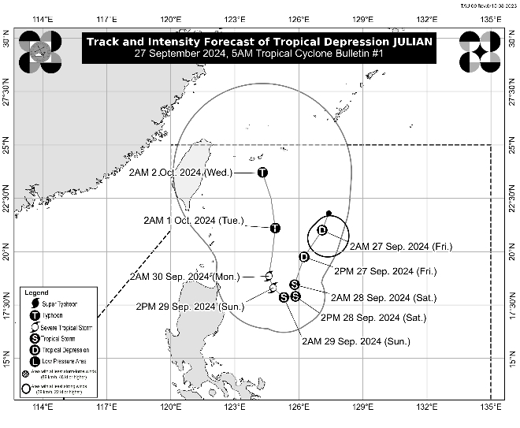
The center of Tropical Depression JULIAN was estimated based on all available data at 525 km East of Itbayat, Batanes (20.9 °N, 126.9°E)
Intensity
Maximum sustained winds of 55 km/h near the center, gustiness of up to 70 km/h, and central pressure of 1004 hPa
Present Movement
South southwestward at 15 km/h
Extent of Tropical Cyclone Winds
Strong winds extend outwards up to 150 km from the center
TRACK AND INTENSITY FORECAST
Date and Time | Center Position |  |  |  | Intensity |  | Movement dir. and speed (km/h)
 | Lat.  (°N) | Lon.  (°E) | Location |  | MSW  (km/h) | Cat.
12-Hour Forecast  2:00 PM  27 September 2024 | 19.8 | 126.3 | 460 km East of Basco, Batanes |  | 55 | TD | SSW 15
24-Hour Forecast  2:00 AM  28 September 2024 | 18.5 | 125.8 | 440 km East of Aparri, Cagayan |  | 65 | TS | SSW 15
36-Hour Forecast  2:00 PM  28 September 2024 | 17.9 | 125.9 | 455 km East of Aparri, Cagayan |  | 75 | TS | S Slowly
48-Hour Forecast  2:00 AM  29 September 2024 | 17.9 | 125.3 | 390 km East of Aparri, Cagayan |  | 85 | TS | W Slowly
60-Hour Forecast  2:00 PM  29 September 2024 | 18.3 | 124.8 | 335 km East of Aparri, Cagayan |  | 95 | STS | NW Slowly
72-Hour Forecast  2:00 AM  30 September 2024 | 18.9 | 124.6 | 330 km East of Calayan, Cagayan |  | 100 | STS | NNW Slowly
96-Hour Forecast  2:00 AM  01 October 2024 | 21.1 | 124.9 | 320 km East of Itbayat, Batanes |  | 120 | TY | N 10
120-Hour Forecast  2:00 AM  02 October 2024 | 23.7 | 124.3 | 410 km Northeast of Itbayat, Batanes |  | 155 | TY | NNW 10

TROPICAL CYCLONE WIND SIGNALS (TCWS) IN EFFECT
No Wind Signal currently hoisted.

OTHER HAZARDS AFFECTING LAND AREAS
Heavy Rainfall Outlook

Refer to Weather Advisory No. 1 issued at 5:00 AM today for the heavy rainfall outlook due to Tropical Depression JULIAN.

Severe Winds

Tropical Cyclone Wind Signal No. 1 may be hoisted over portions of Cagayan Valley within the day. Furthermore, the highest Wind Signal which may be hoisted during the occurrence of JULIAN is Wind Signal No. 2 or 3.

Tropical Depression JULIAN will also bring strong to gale-force gusts over the following areas (especially in coastal and upland areas exposed to winds):

- Tomorrow (28 September): Aurora, Quezon, and Bicol Region
- Sunday (29 September): Aurora, Bataan, Pampanga, Bulacan, Metro Manila, CALABARZON, Romblon, Marinduque, Bicol Region, Western Visayas, Negros Occidental, and Northern Samar.

HAZARDS AFFECTING COASTAL WATERS
24-Hour Sea Condition Outlook

Up to moderate seas over the following coastal waters:
- Up to 2.5 m over the seaboards of Batanes, Cagayan, and Isabela
- Mariners of motorbancas and similarly-sized vessels are advised to take precautionary measures while venturing out to sea and, if possible, avoid navigation under these conditions.

TRACK AND INTENSITY OUTLOOK
- JULIAN is forecast to follow a looping path over the waters east of Batanes and Cagayan in the next five days. Initially, the tropical cyclone will head south southwestward today while decelerating, then move slowly westward tomorrow (28 September) and northwestward on Sunday (29 September), before accelerating generally northward on Monday (30 September) and Tuesday (01 October).
- The tropical depression will continuously intensify throughout the forecast period and may reach tropical storm category tonight or tomorrow morning. Furthermore, it will be at severe tropical storm and typhoon categories by Sunday and Tuesday, respectively.

Considering these developments, the public and disaster risk reduction and management offices concerned are advised to take all necessary measures to protect life and property. Persons living in areas identified to be highly or very highly susceptible to these hazards are advised to follow evacuation and other instructions from local officials. For heavy rainfall warnings, thunderstorm/rainfall advisories, and other severe weather information specific to your area, please monitor products issued by your local PAGASA Regional Services Division.

The next tropical cyclone bulletin will be issued at 11:00 AM today.

DOST-PAGASA

