TROPICAL DEPRESSION “JULIAN” REMAINS ALMOST STATIONARY OVER THE PHILIPPINE SEA EAST OF BATANES.
Location of Center (10:00 AM) |  |  |  | 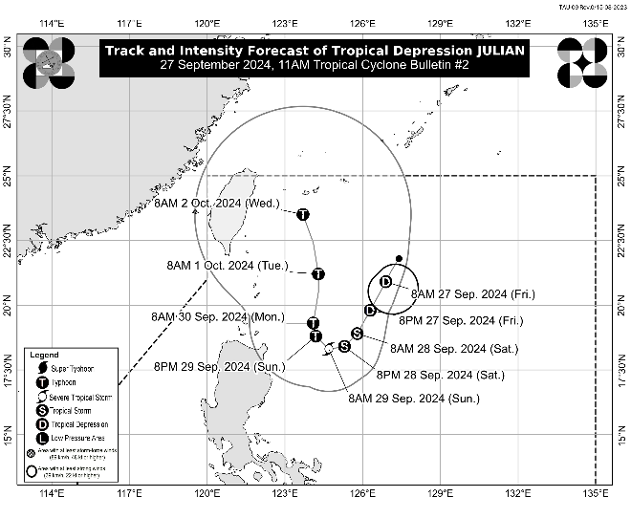
The center of Tropical Depression JULIAN was estimated based on all available data at 525 km East of Itbayat, Batanes (20.9 °N, 126.9°E)
Intensity
Maximum sustained winds of 55 km/h near the center, gustiness of up to 70 km/h, and central pressure of 1004 hPa
Present Movement
Almost stationary
Extent of Tropical Cyclone Winds
Strong winds extend outwards up to 150 km from the center
TRACK AND INTENSITY FORECAST
Date and Time | Center Position |  |  |  | Intensity |  | Movement dir. and speed (km/h)
 | Lat.  (°N) | Lon.  (°E) | Location |  | MSW  (km/h) | Cat.
12-Hour Forecast  8:00 PM  27 September 2024 | 19.8 | 126.3 | 460 km East of Basco, Batanes |  | 55 | TD | SSW 10
24-Hour Forecast  8:00 AM  28 September 2024 | 18.9 | 125.8 | 460 km East of Calayan, Cagayan |  | 65 | TS | SSW 10
36-Hour Forecast  8:00 PM  28 September 2024 | 18.4 | 125.3 | 390 km East of Aparri, Cagayan |  | 85 | TS | SW Slowly
48-Hour Forecast  8:00 AM  29 September 2024 | 18.3 | 124.7 | 325 km East of Aparri, Cagayan |  | 95 | STS | W Slowly
60-Hour Forecast  8:00 PM  29 September 2024 | 18.8 | 124.2 | 290 km East of Calayan, Cagayan |  | 120 | TY | NW Slowly
72-Hour Forecast  8:00 AM  30 September 2024 | 19.3 | 124.1 | 275 km East of Calayan, Cagayan |  | 130 | TY | N Slowly
96-Hour Forecast  8:00 AM  01 October 2024 | 21.2 | 124.3 | 260 km East of Itbayat, Batanes |  | 140 | TY | N 10
120-Hour Forecast  8:00 AM  02 October 2024 | 23.5 | 123.7 | 360 km North Northeast of Itbayat, Batanes |  | 150 | TY | NNW 10

TROPICAL CYCLONE WIND SIGNALS (TCWS) IN EFFECT
No Wind Signal currently hoisted.

OTHER HAZARDS AFFECTING LAND AREAS
Heavy Rainfall Outlook

Refer to Weather Advisory No. 2 issued at 11:00 AM today for the heavy rainfall outlook due to Tropical Depression JULIAN.

Severe Winds

Tropical Cyclone Wind Signal No. 1 may be hoisted over portions of Cagayan Valley within the day. Furthermore, the highest Wind Signal which may be hoisted during the occurrence of JULIAN is Wind Signal No. 2 or 3.

Furthermore, the wind flow coming towards the circulation of Tropical Depression JULIAN may also bring strong to gale-force gusts over the following areas (especially in coastal and upland areas exposed to winds):

- Tomorrow (28 September): Aurora and the northern portion of Quezon
- Sunday (29 September): Aurora, CALABARZON, Romblon, Marinduque, Bicol Region, Aklan, and the northern portion of Antique

HAZARDS AFFECTING COASTAL WATERS
24-Hour Sea Condition Outlook

Sea condition may become rough over the following coastal waters:
- Up to 3.0 m over the seaboards of Batanes and Babuyan Islands and the eastern seaboard of mainland Cagayan.
- Mariners of small seacrafts, including all types of motorbancas, are advised not to venture out to sea under these conditions, especially if inexperienced or operating ill-equipped vessels

Sea condition may become moderate over the following coastal waters:
- Up to 2.5 m over the remaining seaboard of Cagayan and seaboard of Isabela
- Mariners of motorbancas and similarly-sized vessels are advised to take precautionary measures while venturing out to sea and, if possible, avoid navigation under these conditions.

TRACK AND INTENSITY OUTLOOK
- JULIAN is forecast to follow a looping path over the waters east of Batanes and Cagayan in the next five days. Initially, the tropical cyclone will head south southwestward or southwestward today and tomorrow (28 September) while decelerating, then move slowly westward to northwestward on Sunday (29 September), before accelerating generally northward from Monday (30 September) onwards.
- The tropical depression will continuously intensify throughout the forecast period and may reach tropical storm category tonight or tomorrow morning. Furthermore, it may become a typhoon on Sunday.

Considering these developments, the public and disaster risk reduction and management offices concerned are advised to take all necessary measures to protect life and property. Persons living in areas identified to be highly or very highly susceptible to these hazards are advised to follow evacuation and other instructions from local officials. For heavy rainfall warnings, thunderstorm/rainfall advisories, and other severe weather information specific to your area, please monitor products issued by your local PAGASA Regional Services Division.

The next tropical cyclone bulletin will be issued at 5:00 PM today.

DOST-PAGASA

