“JULIAN” MAINTAINS ITS STRENGTH WHILE DECELERATING SOUTHWARD OVER THE PHILIPPINE SEA
Location of Center (4:00 AM) |  |  |  | 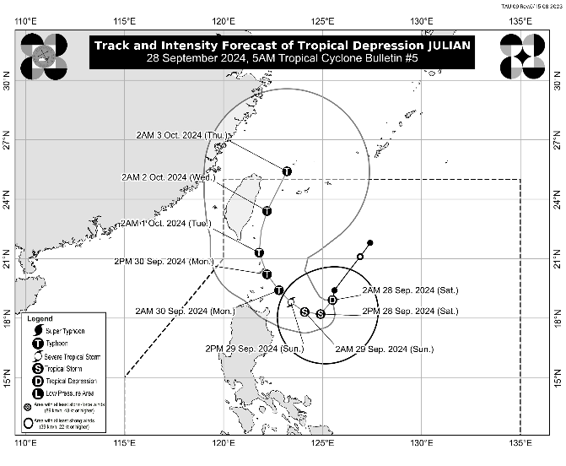
The center of Tropical Depression JULIAN was estimated based on all available data at 400 km East of Aparri, Cagayan (18.6 °N, 125.4°E)
Intensity
Maximum sustained winds of 55 km/h near the center, gustiness of up to 70 km/h, and central pressure of 1002 hPa
Present Movement
Southward at 10 km/h
Extent of Tropical Cyclone Winds
Strong winds extend outwards up to 360 km from the center
TRACK AND INTENSITY FORECAST
Date and Time | Center Position |  |  |  | Intensity |  | Movement dir. and speed (km/h)
 | Lat.  (°N) | Lon.  (°E) | Location |  | MSW  (km/h) | Cat.
12-Hour Forecast  2:00 PM  28 September 2024 | 18.2 | 124.9 | 345 km East of Aparri, Cagayan |  | 65 | TS | SW 10
24-Hour Forecast  2:00 AM  29 September 2024 | 18.3 | 124.1 | 260 km East of Aparri, Cagayan |  | 85 | TS | W Slowly
36-Hour Forecast  2:00 PM  29 September 2024 | 18.8 | 123.4 | 195 km East Northeast of Aparri, Cagayan |  | 100 | STS | NW 10
48-Hour Forecast  2:00 AM  30 September 2024 | 19.4 | 122.8 | Over the coastal waters of Calayan, Cagayan |  | 120 | TY | NW 10
60-Hour Forecast  2:00 PM  30 September 2024 | 20.2 | 122.2 | Over the coastal waters of Uyugan, Batanes |  | 140 | TY | NW 10
72-Hour Forecast  2:00 AM  01 October 2024 | 21.3 | 121.8 | Over the coastal waters of Itbayat, Batanes |  | 155 | TY | NNW 10
96-Hour Forecast  2:00 AM  02 October 2024 | 23.4 | 122.2 | 295 km North of Itbayat, Batanes |  | 165 | TY | N 10
120-Hour Forecast  2:00 AM  03 October 2024 | 25.4 | 123.2 | 530 km North Northeast of Itbayat, Batanes |  | 155 | TY | NNE 10

TROPICAL CYCLONE WIND SIGNALS (TCWS) IN EFFECT
TCWS No. | Luzon | Visayas | Mindanao
1  Wind threat: Strong winds | Cagayan including Babuyan Islands, the northeastern portion of Isabela (San Pablo, Divilacan, Maconacon, Palanan, Cabagan, Santa Maria, Tumauini, Ilagan City, San Mariano, Santo Tomas, Delfin Albano), and the eastern portion of Apayao (Luna, Pudtol, Santa Marcela, Flora) | - | -
Warning lead time: 36 hours
Range of wind speeds: 39 to 61 km/h (Beaufort 6 to 7)
Potential impacts of winds: Minimal to minor threat to life and property

OTHER HAZARDS AFFECTING LAND AREAS
Heavy Rainfall Outlook

Refer to Weather Advisory No. 5 issued at 5:00 AM today for the heavy rainfall outlook due to Tropical Depression JULIAN.

Severe Winds

The wind signals warn the public of the general wind threat over an area due to the tropical cyclone. Local winds may be slightly stronger/enhanced in coastal and upland/mountainous areas exposed to winds. Winds are less strong in areas sheltered from the prevailing wind direction.

- Minimal to minor impacts from strong winds are possible within any of the areas under Wind Signal No. 1.

The highest Wind Signal that may be hoisted during the occurrence of JULIAN is Wind Signal No. 4.

Furthermore, the wind flow coming towards the circulation of Tropical Depression JULIAN may also bring strong to gale-force gusts over the following areas (especially in coastal and upland areas exposed to winds):

- Today (28 September): Aurora, Quezon, Camarines Norte, Camarines Sur, and Catanduanes
- Tomorrow (29 September): Aurora, CALABARZON, Oriental Mindoro, Romblon, Marinduque, Bicol Region, Aklan, and the northern portion of Antique
- Monday (30 September): Pangasinan, Zambales, Bataan, Aurora, Metro Manila, CALABARZON, Oriental Mindoro, Romblon, Marinduque, and Bicol Region

HAZARDS AFFECTING COASTAL WATERS
24-Hour Sea Condition Outlook

Rough sea condition over the following coastal waters:
- Up to 4.0 m over the seaboards of Batanes, Babuyan Islands, and the eastern seaboard of mainland Cagayan.
- Mariners of small seacrafts, including all types of motorbancas, are advised not to venture out to sea under these conditions, especially if inexperienced or operating ill-equipped vessels

Moderate sea condition over the following coastal waters:
- Up to 3.0 m over the remaining seaboard of Cagayan and seaboard of Isabela
- Mariners of motorbancas and similarly-sized vessels are advised to take precautionary measures while venturing out to sea and, if possible, avoid navigation under these conditions.

The hoisting of a Gale Warning is also increasingly likely over seaboards of Northern Luzon.

TRACK AND INTENSITY OUTLOOK
- JULIAN is forecast to follow a looping path over the waters east of Batanes and Cagayan in the next five days. Within the next 12 hours, this tropical cyclone is forecast to move southwestward before turning westward this afternoon while decelerating. It will then move generally northwestward from tomorrow (29 September) until Tuesday (1 October) before turning northward to north northeastward for the remaining of the forecast period. Based on the latest forecast track, JULIAN may possibly make landfall over Batanes by Monday afternoon or evening as a typhoon and may exit the Philippine Area of Responsibility by Wednesday (2 October) evening to Thursday (3 October) early morning.
- JULIAN will continue to intensify throughout the forecast period and may reach tropical storm category today. It may reach typhoon category by Monday. There is an increasing likelihood of rapid intensification, and the possibility of reaching super typhoon category is not ruled out.

Considering these developments, the public and disaster risk reduction and management offices concerned are advised to take all necessary measures to protect life and property. Persons living in areas identified to be highly or very highly susceptible to these hazards are advised to follow evacuation and other instructions from local officials. For heavy rainfall warnings, thunderstorm/rainfall advisories, and other severe weather information specific to your area, please monitor products issued by your local PAGASA Regional Services Division.

The next tropical cyclone bulletin will be issued at 11:00 AM today.

DOST-PAGASA

