“JULIAN” SLIGHTLY INTENSIFIES AS IT MOVES OVER THE PHILIPPINE SEA EAST OF CAGAYAN.
Location of Center (4:00 PM) |  |  |  | 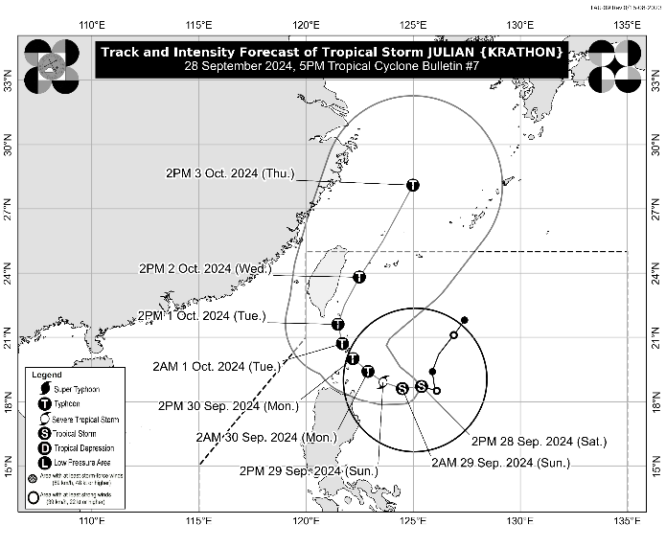
The center of Tropical Storm JULIAN was estimated based on all available data at 380 km East of Aparri, Cagayan (18.6°N, 125.2°E)
Intensity
Maximum sustained winds of 75 km/h near the center, gustiness of up to 90 km/h, and central pressure of 996 hPa
Present Movement
West northwestward at 15 km/h
Extent of Tropical Cyclone Winds
Strong to gale-force winds extend outwards up to 420 km from the center
TRACK AND INTENSITY FORECAST
Date and Time | Center Position |  |  |  | Intensity |  | Movement dir. and speed (km/h)
 | Lat.  (°N) | Lon.  (°E) | Location |  | MSW  (km/h) | Cat.
12-Hour Forecast  2:00 AM  29 September 2024 | 18.6 | 124.5 | 305 km East of Aparri, Cagayan |  | 85 | TS | W 10
24-Hour Forecast  2:00 PM  29 September 2024 | 18.9 | 123.6 | 215 km East Northeast of Aparri, Cagayan |  | 100 | STS | WNW 10
36-Hour Forecast  2:00 AM  30 September 2024 | 19.4 | 122.9 | 150 km Southeast of Basco, Batanes |  | 130 | TY | NW 10
48-Hour Forecast  2:00 PM  30 September 2024 | 20.0 | 122.2 | Over the coastal waters of Balintang Is., Calayan, Cagayan |  | 150 | TY | NW 10
60-Hour Forecast  2:00 AM  01 October 2024 | 20.7 | 121.7 | Over the coastal waters of Itbayat, Batanes |  | 165 | TY | NW 10
72-Hour Forecast  2:00 PM  01 October 2024 | 21.6 | 121.5 | 95 km North Northwest of Itbayat, Batanes |  | 175 | TY | NNW 10
96-Hour Forecast  2:00 PM  02 October 2024 | 23.8 | 122.5 | 340 km North Northeast of Itbayat, Batanes |  | 165 | TY | NNE 10
120-Hour Forecast  2:00 PM  03 October 2024 | 28.1 | 125.0 | 875 km North Northeast of Extreme Northern Luzon (OUTSIDE PAR) |  | 155 | TY | NNE 20

TROPICAL CYCLONE WIND SIGNALS (TCWS) IN EFFECT
TCWS No. | Luzon | Visayas | Mindanao
1  Wind threat: Strong winds | Batanes, Cagayan including Babuyan Islands, Isabela, Apayao, Kalinga, the eastern portion of Mountain Province (Natonin, Paracelis), the eastern portion of Ifugao (Aguinaldo, Alfonso Lista), Ilocos Norte, Abra, and the northern portion of Aurora (Dilasag, Casiguran) | - | -
Warning lead time: 36 hours
Range of wind speeds: 39 to 61 km/h (Beaufort 6 to 7)
Potential impacts of winds: Minimal to minor threat to life and property

OTHER HAZARDS AFFECTING LAND AREAS
Heavy Rainfall Outlook

Refer to Weather Advisory No. 7 issued at 5:00 PM today for the heavy rainfall outlook due to Tropical Storm JULIAN.

Severe Winds

The wind signals warn the public of the general wind threat over an area due to the tropical cyclone. Local winds may be slightly stronger/enhanced in coastal and upland/mountainous areas exposed to winds. Winds are less strong in areas sheltered from the prevailing wind direction.

- Minimal to minor impacts from strong winds are possible within any of the areas under Wind Signal No. 1.

The highest Wind Signal that may be hoisted during the occurrence of JULIAN is Wind Signal No. 4.

Furthermore, the wind flow coming towards the circulation of Tropical Depression JULIAN may also bring strong to gale-force gusts over the following areas (especially in coastal and upland areas exposed to winds):

- Tomorrow (29 September): Aurora, CALABARZON, Romblon, and Bicol Region
- Monday (30 September): Aurora, Pangasinan, Zambales, Bataan, Metro Manila, CALABARZON, Romblon, and Bicol Region.

HAZARDS AFFECTING COASTAL WATERS
24-Hour Sea Condition Outlook

Very rough sea condition over the following coastal waters:
- Up to 6.0 m over the seaboards of Batanes
- Up to 5.0 m over the seaboards of Babuyan Islands
- Sea travel is risky for most types or tonnage of vessels. Mariners of these vessels are advised to remain in port or seek safe shelter or harbor.

Rough sea condition over the following coastal waters
- Up to 4.0 m over the northern seaboard of mainland Cagayan
- Up to 3.5 m over the northern seaboard of Ilocos Norte and the remaining seaboard of Cagayan
- Up to 3.0 m over the seaboard of Isabela and the northern portion of Aurora
- Mariners of small seacrafts, including all types of motorbancas, are advised not to venture out to sea under these conditions, especially if inexperienced or operating ill-equipped vessels

Moderate sea condition over the following coastal waters:
- Up to 2.5 m and the remaining seaboard of Ilocos Norte
- Mariners of motorbancas and similarly-sized vessels are advised to take precautionary measures while venturing out to sea and, if possible, avoid navigation under these conditions.

A Gale Warning may be hoisted over the seaboards of Batanes and Babuyan Islands tonight.

TRACK AND INTENSITY OUTLOOK
- JULIAN is forecast to move west southwestward or westward today through tomorrow (29 September) afternoon, then generally northwestward for the rest of tomorrow through Tuesday (1 October) towards the Batanes-Babuyan Islands area, before accelerating north northeastward over the waters east of Taiwan for the rest of Tuesday (1 October) onwards. On the track forecast, a landfall or close approach scenario on Monday through Tuesday early morning over Batanes and/or Babuyan Islands is highly likely.
- JULIAN will continue to intensify throughout the forecast period and reach typhoon category on Monday. There is high chance of rapid intensification, and the possibility of reaching super typhoon category is not ruled out. This tropical cyclone will be closest to Batanes and/or Babuyan Islands at or near peak intensity.

Considering these developments, the public and disaster risk reduction and management offices concerned are advised to take all necessary measures to protect life and property. Persons living in areas identified to be highly or very highly susceptible to these hazards are advised to follow evacuation and other instructions from local officials. For heavy rainfall warnings, thunderstorm/rainfall advisories, and other severe weather information specific to your area, please monitor products issued by your local PAGASA Regional Services Division.

The next tropical cyclone bulletin will be issued at 11:00 PM today.

DOST-PAGASA

