“JULIAN” INTENSIFIES INTO A SEVERE TROPICAL STORM.
Location of Center (4:00 AM) |  |  |  | 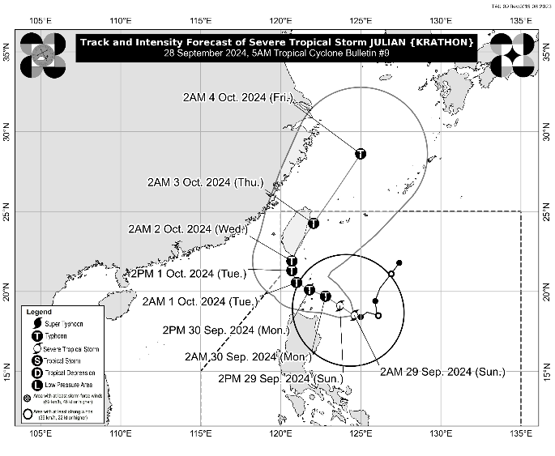
The center of Severe Tropical Storm JULIAN was estimated based on all available data at 305 km East of Aparri, Cagayan (18.6°N, 124.5°E)
Intensity
Maximum sustained winds of 95 km/h near the center, gustiness of up to 115 km/h, and central pressure of 990 hPa
Present Movement
West northwestward at 10 km/h
Extent of Tropical Cyclone Winds
Strong to storm-force winds extend outwards up to 450 km from the center
TRACK AND INTENSITY FORECAST
Date and Time | Center Position |  |  |  | Intensity |  | Movement dir. and speed (km/h)
 | Lat.  (°N) | Lon.  (°E) | Location |  | MSW  (km/h) | Cat.
12-Hour Forecast  2:00 PM  29 September 2024 | 19.1 | 123.7 | 235 km East of Calayan, Cagayan |  | 110 | STS | NW 10
24-Hour Forecast  2:00 AM  30 September 2024 | 19.7 | 122.8 | 120 km Southeast of Basco, Batanes |  | 130 | TY | NW 10
36-Hour Forecast  2:00 PM  30 September 2024 | 20.1 | 121.8 | Over the coastal waters of Sabtang Is., Batanes |  | 155 | TY | WNW 10
48-Hour Forecast  2:00 AM  01 October 2024 | 20.6 | 121.0 | 90 km West Southwest of Itbayat, Batanes |  | 165 | TY | WNW 10
60-Hour Forecast  2:00 PM  01 October 2024 | 21.3 | 120.7 | 130 km West Northwest of Itbayat, Batanes |  | 175 | TY | NNW Slowly
72-Hour Forecast  2:00 AM  02 October 2024 | 21.9 | 120.7 | 170 km Northwest of Itbayat, Batanes |  | 175 | TY | N Slowly
96-Hour Forecast  2:00 AM  03 October 2024 | 24.3 | 122.1 | 390 km North of Itbayat, Batanes |  | 150 | TY | NNE 10
120-Hour Forecast  2:00 AM  04 October 2024 | 28.6 | 125.0 | 925 km North Northeast of Extreme Northern Luzon (OUTSIDE PAR) |  | 150 | TY | NNE 25

TROPICAL CYCLONE WIND SIGNALS (TCWS) IN EFFECT
TCWS No. | Luzon | Visayas | Mindanao
2  Wind threat:  Gale-Force winds | The northeastern portion of Mainland Cagayan (Santa Ana) and the eastern portion of Babuyan Islands (Camiguin Is., Babuyan Is.) | - | -
Warning lead time: 24 hours
Range of wind speeds: 62 to 88 km/h (Beaufort 8 to 9)
Potential impacts of winds: Minor to moderate threat to life and property
1  Wind threat:  Strong winds | Batanes, the rest of Cagayan, the rest of Babuyan Islands, Isabela, Apayao, Abra, Kalinga, the eastern and central portions of Mountain Province (Natonin, Paracelis, Sadanga, Barlig, Bontoc), the eastern portion of Ifugao (Aguinaldo, Alfonso Lista, Mayoyao), Ilocos Norte, the northern portion of Ilocos Sur (Sinait, Cabugao, San Juan, Magsingal, Santo Domingo, Bantay, San Ildefonso, San Vicente), and the northern portion of Aurora (Dilasag, Casiguran) | - | -
Warning lead time: 36 hours
Range of wind speeds: 39 to 61 km/h (Beaufort 6 to 7)
Potential impacts of winds: Minimal to minor threat to life and property

OTHER HAZARDS AFFECTING LAND AREAS
Heavy Rainfall Outlook

Refer to Weather Advisory No. 9 issued at 5:00 AM today for the heavy rainfall outlook due to Severe Tropical Storm JULIAN.

Severe Winds

The wind signals warn the public of the general wind threat over an area due to the tropical cyclone. Local winds may be slightly stronger/enhanced in coastal and upland/mountainous areas exposed to winds. Winds are less strong in areas sheltered from the prevailing wind direction.

- Minor to moderate impacts from strong winds are possible within any of the localities where Wind Signal No. 2 is hoisted.
- Minimal to minor impacts from strong winds are possible within any of the areas under Wind Signal No. 1.

The highest Wind Signal that may be hoisted during the occurrence of JULIAN is Wind Signal No. 4.

Furthermore, the wind flow coming towards the circulation of Severe Tropical Storm JULIAN may also bring strong to gale-force gusts over the following areas (especially in coastal and upland areas exposed to winds):

- Today (29 September): Aurora, CALABARZON, Romblon, and Bicol Region
- Tomorrow (30 September): Pangasinan, Zambales, Bataan, Aurora, Quezon, Romblon, and Bicol Region.

HAZARDS AFFECTING COASTAL WATERS
24-Hour Sea Condition Outlook

A Gale Warning is hoisted over the northern and eastern seaboards of Northern Luzon. Sea travel is risky for small seacrafts, including all types of motorbancas. For more information, refer to Gale Warning No. 2 issued at 5:00 AM today.

Very rough sea condition over the following coastal waters:
- Up to 8.0 m over the seaboards of Batanes
- Up to 6.0 m over the seaboards of Babuyan Islands
- Sea travel is risky for most types or tonnage of vessels. Mariners of these vessels are advised to remain in port or seek safe shelter or harbor.

Rough sea condition over the following coastal waters
- Up to 4.0 m over the northern seaboard of mainland Cagayan and the northern seaboard of Ilocos Norte
- Up to 3.5 m over and the remaining seaboard of Cagayan and the seaboard of Isabela
- Up to 3.0 m over the seaboard of the northern portion of Aurora
- Mariners of small seacrafts, including all types of motorbancas, are advised not to venture out to sea under these conditions, especially if inexperienced or operating ill-equipped vessels

Moderate sea condition over the following coastal waters:
- Up to 2.5 m and the remaining seaboard of Ilocos Norte
- Mariners of motorbancas and similarly-sized vessels are advised to take precautionary measures while venturing out to sea and, if possible, avoid navigation under these conditions.

TRACK AND INTENSITY OUTLOOK
- JULIAN is forecast to move generally northwestward to west northwestward from today through Tuesday (1 October) morning towards the Batanes-Babuyan Islands area, before accelerating north to north northeastward over the waters east of Taiwan for the rest of Tuesday onwards. On the track forecast, a landfall or close approach scenario by tomorrow (30 September) over Batanes and/or Babuyan Islands is highly likely.
- JULIAN will continue to intensify throughout the forecast period and reach typhoon category by this evening or tomorrow early morning. There is high chance of rapid intensification, and the possibility of reaching super typhoon category is not ruled out. This tropical cyclone will be closest to Batanes and/or Babuyan Islands at or near peak intensity.

Considering these developments, the public and disaster risk reduction and management offices concerned are advised to take all necessary measures to protect life and property. Persons living in areas identified to be highly or very highly susceptible to these hazards are advised to follow evacuation and other instructions from local officials. For heavy rainfall warnings, thunderstorm/rainfall advisories, and other severe weather information specific to your area, please monitor products issued by your local PAGASA Regional Services Division.

The next tropical cyclone bulletin will be issued at 11:00 AM today.

DOST-PAGASA

